f¡W-4z VOIP- Basic fun and emp of IP Phone and ATA, Installation of Elastix Server.

Voice over IP: Voice over IP (VoIP) is a methodology and group of technologies for the delivery of voice communications and multimedia sessions over Internet Protocol (IP) networks, such as the Internet. Other terms commonly associated with VoIP are IP telephony, Internet telephony, broadband telephony, and broadband phone service.

rotocols
Voice over IP has been implemented in various ways using both proprietary protocols and protocols based on open standards. Examples of the VoIP protocols are:

1. H.323
2. Media Gateway Control Protocol (MGCP)
3. Session Initiation Protocol (SIP)
4. H.248 (also known as Media Gateway Control (Megaco))
5. Real-time Transport Protocol (RTP)
6. Real-time Transport Control Protocol (RTCP)
7. Secure Real-time Transport Protocol (SRTP)
8. Session Description Protocol (SDP)
9. Inter-Asterisk eXchange (IAX)
10. JingleXMPP VoIP extensions
11. Skype protocol
12. Teamspeak

The H.323 protocol was one of the first VoIP protocols that found widespread implementation for long-distance traffic, as well aslocal area network services. However, since the development of newer, less complex protocols such as MGCP and SIP, H.323 deployments are increasingly limited to carrying existing long-haul network traffic. In particular, the Session Initiation Protocol (SIP) has gained widespread VoIP market penetration.

Why VOIP

1. Cost reduction
2. Toll by-pass
3. WAN cost reduction
4. Operational improvement
5. Common network infrastructure
6. Simplification of routing administration
7. Business tool integration
8. Voice mail, email and fax mail integration
9. Web + call
10. Mobility using IP
Concept OF VOIP

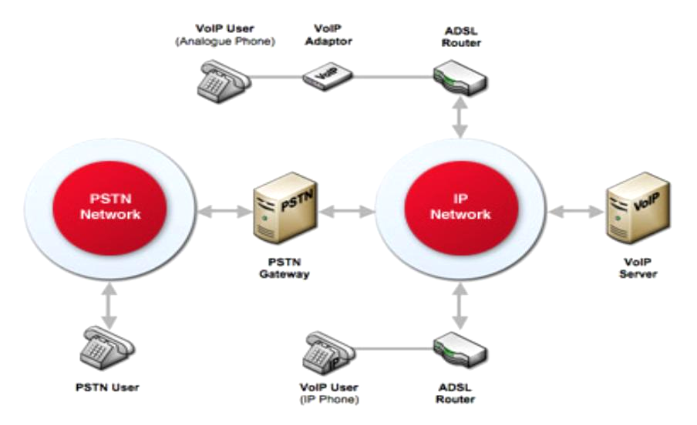

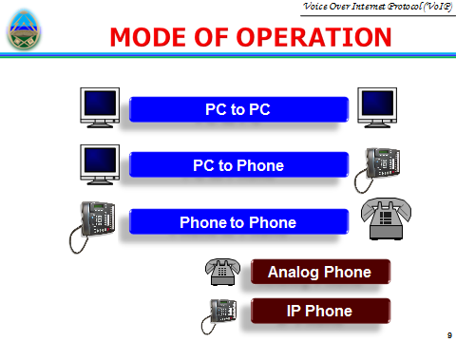
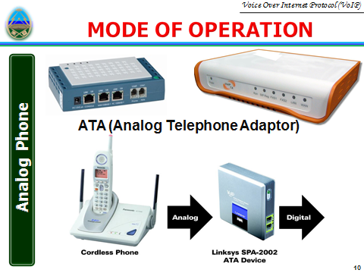

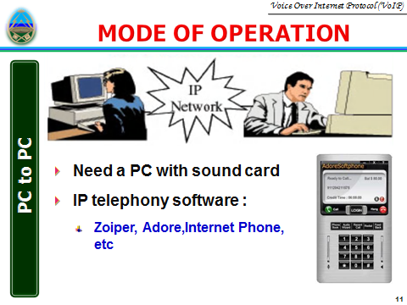
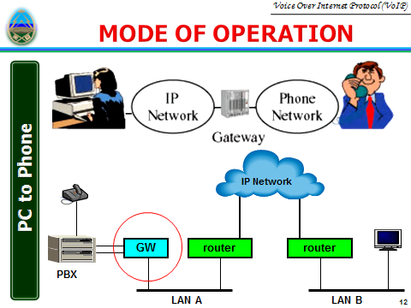

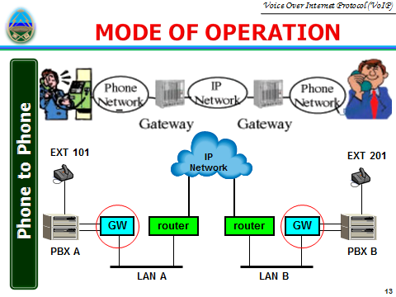
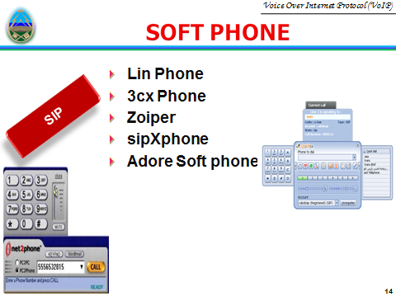

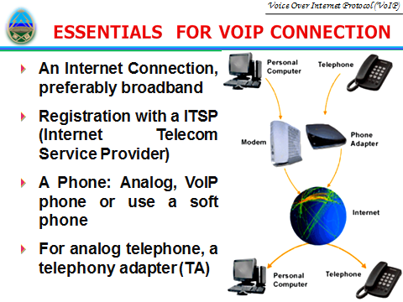

1.1 Hardware

First you shall prepare the following items: A PC with an empty HDD and DIGIUM with FXO Card.

1.2 Software
Make sure you have these software: Elastix 2.0.3
Elastix 2.0.3, about 682MB in size, can be downloaded from:
http://downloads.sourceforge.net/project/elastix/Elastix%20PBX%20Appliance%20Software/2.0.3/Elastix-2.0.3-i386-bin-15Nov2010.iso
Then burn the downloaded driver into a CD.

Installation of Elastix 2.0.3 System
2.1 Brief Introduction to Elastix System

The Elastix system is an integrated system which includes the operating system CentOS and other software like Asterisk, Dahdi, FreePBX. All necessary software can be installed well at one time, not requiring independent peration for any one of them. Then Asterisk and relative services will be automatically started up upon installation.
For detailed information about Elastix, please go to the official website of Elastix:
http://www.elastix.org.

2.2 Installation of Elastix System

Step1: Set the guide mode

Set BIOS to boot from CD-ROM. Put the CD of Elastix system burned already into CD-ROM and start the PC.
Step2: Install Elastix

1. The system will go into the CD guide after the PC being started. Then the following interface will be shown on the screen. See Figure 1. Press Enter directly to go into the default installation mode.( Figure 1)
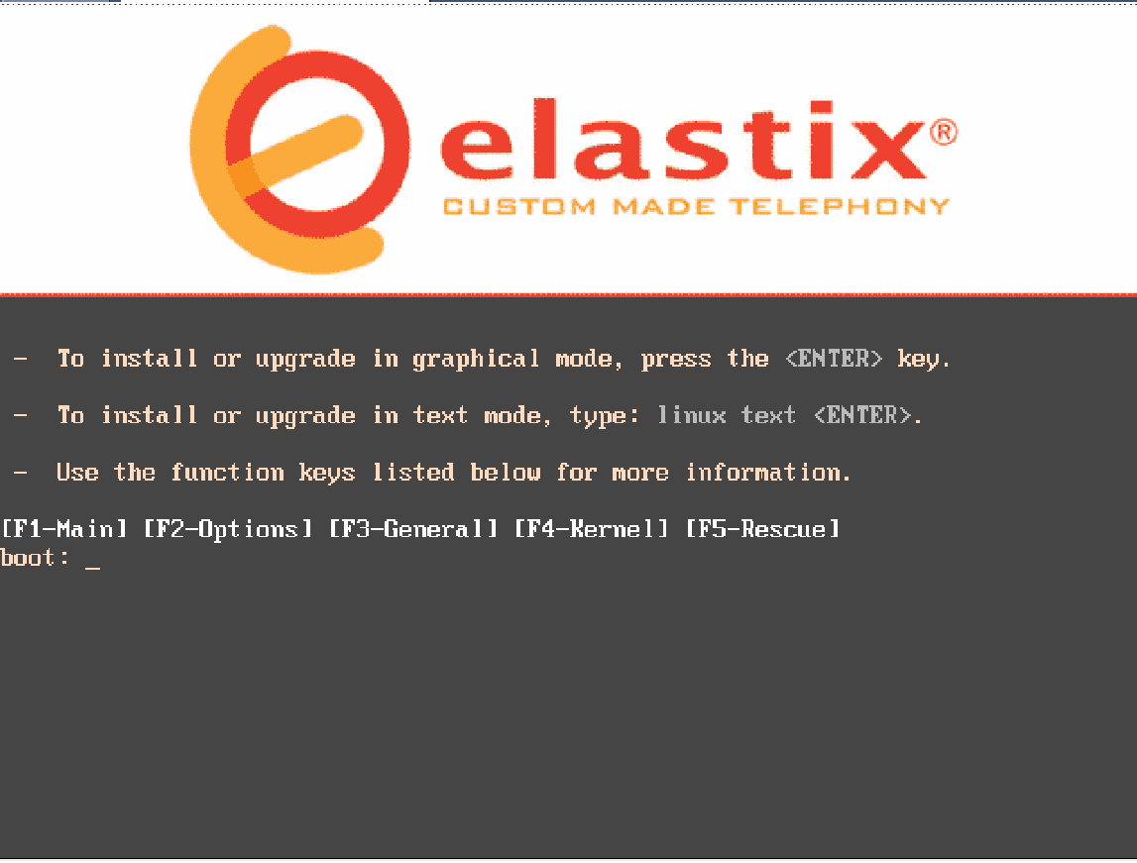
2. Next, choose the language for installation. Here select ‘English’ (Figure 2).

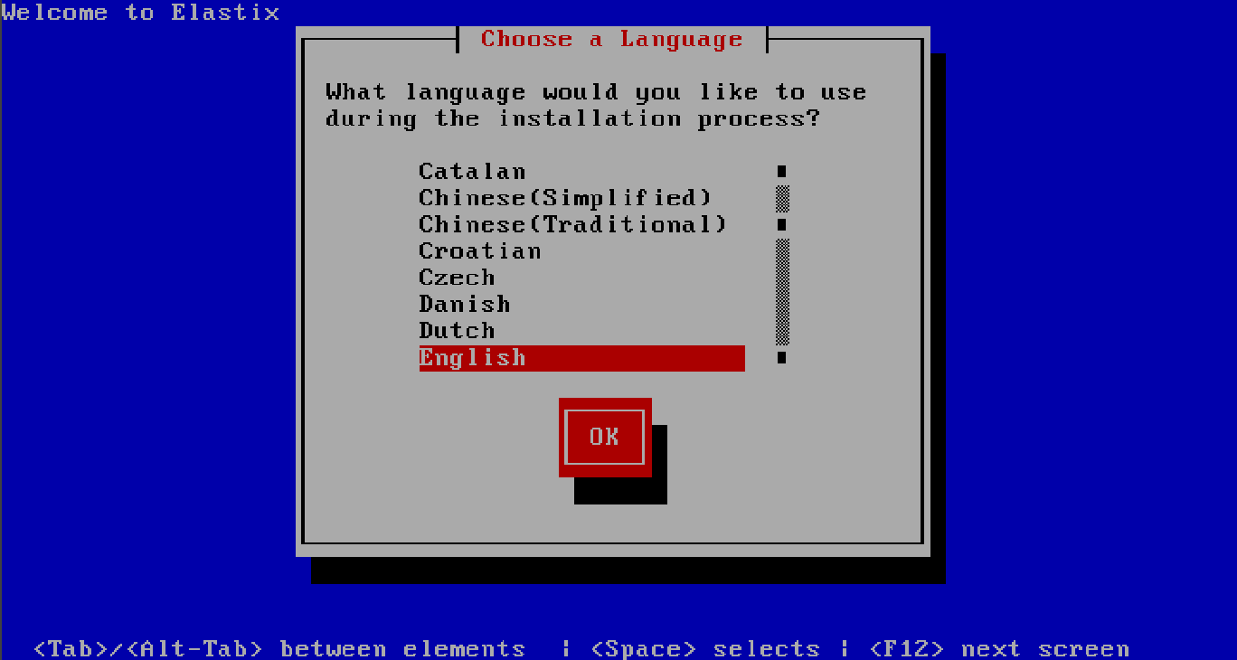
3. Next, choose a keyboard type according to your requirement. Usually we choose ‘us’ (Figure 3).
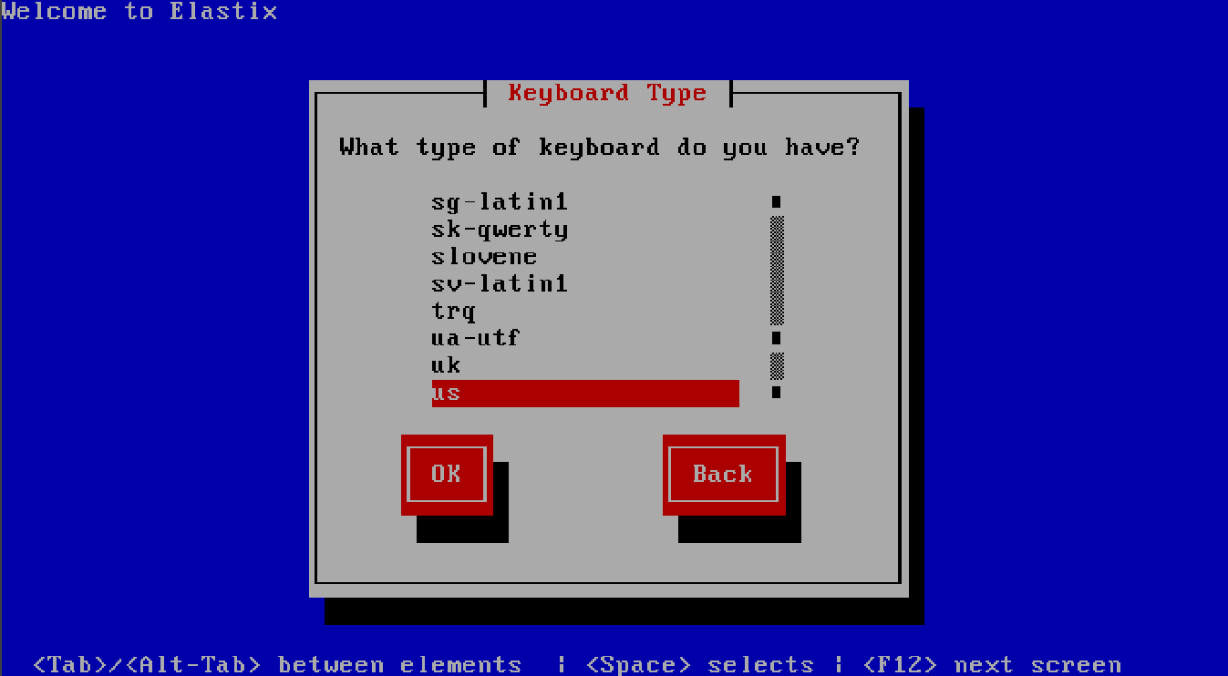

4. Next is the partitioning operation. You have four options to select. For a brand new HDD, select the default setting ‘Use free space on selected drivers and create default layout’. For an HDD with some data already, if you want to discard it, use the option ‘Remove all partitions on selected drivers and create default layout’; if you want to keep the old data, select the option ‘Create custom layout’ to do partitioning. What we use here is a new HDD. Select the default setting and click on ‘OK’ (Figure 4).
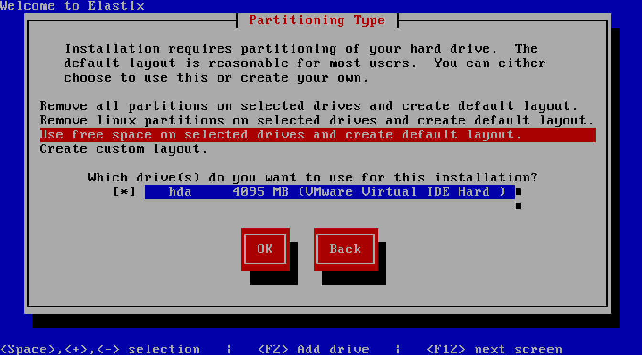

5. Next, the following prompt ‘Review and modify partitioning layout?’ pops up. Select ‘No’ here (Figure 5).
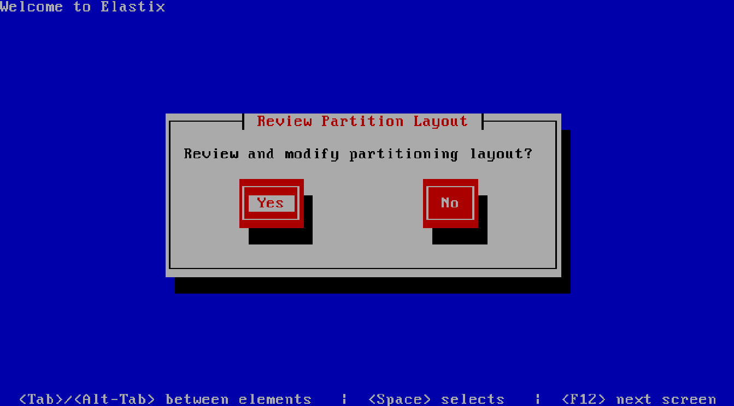
6. Next, the following prompt ‘Would you like to configure the eth0 network interface in your system?’ pops up. Select ‘Yes’ here (Figure 6).

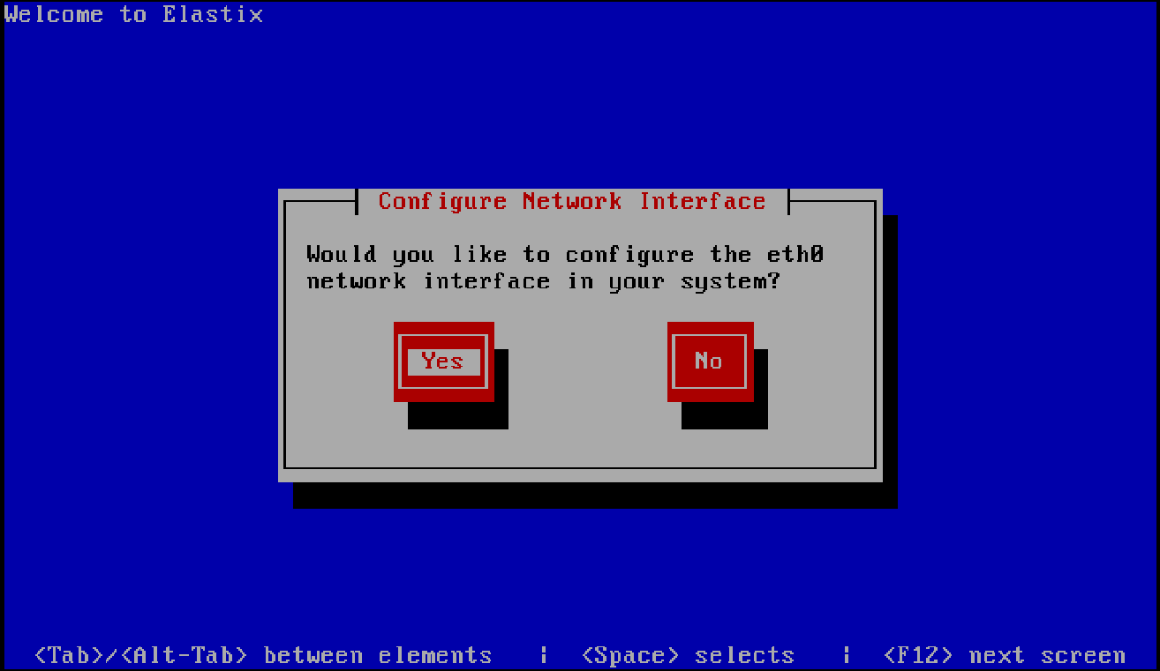

7. Next, choose to configure IPv4 or IPv6. Here we select ‘Activate on boot’ and ‘Enable IPv4 support’, and then click ‘OK’ (Figure 7).
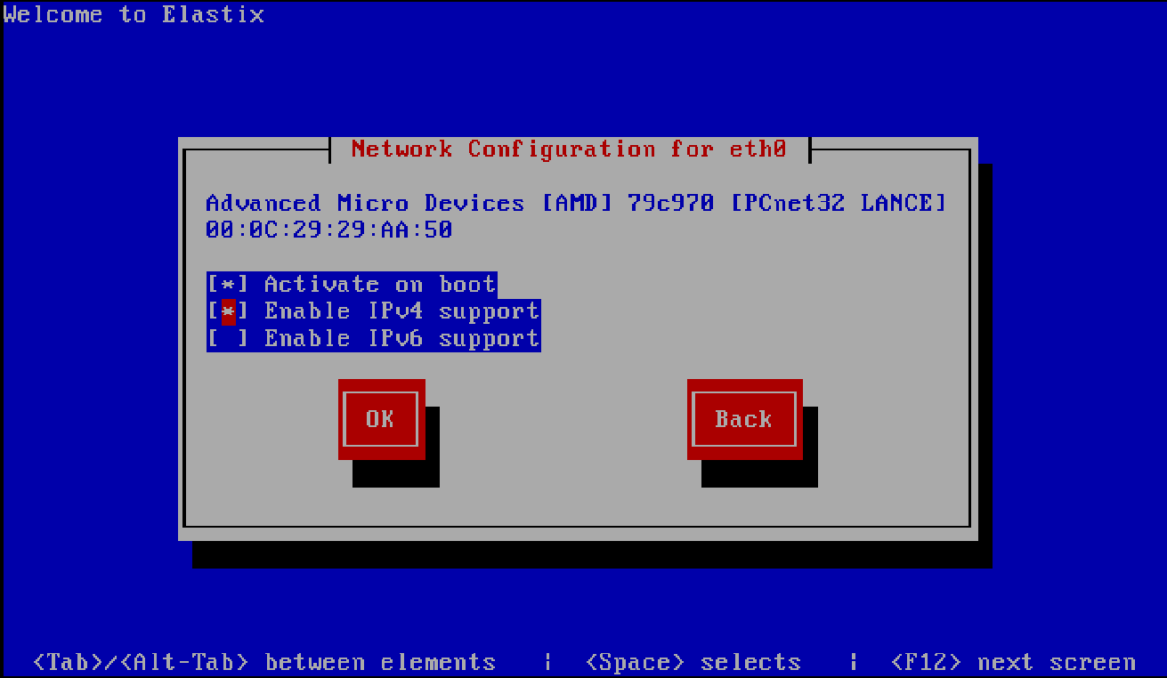

8. Next, choose to manually or dynamically configure IP address. Here we select ‘Manual address configuration’, enter the IP address and the subnet mask below, and then click ‘OK’ (Figure 8).
IP : 192.168.55.1
Prefix : 255.255.255.0

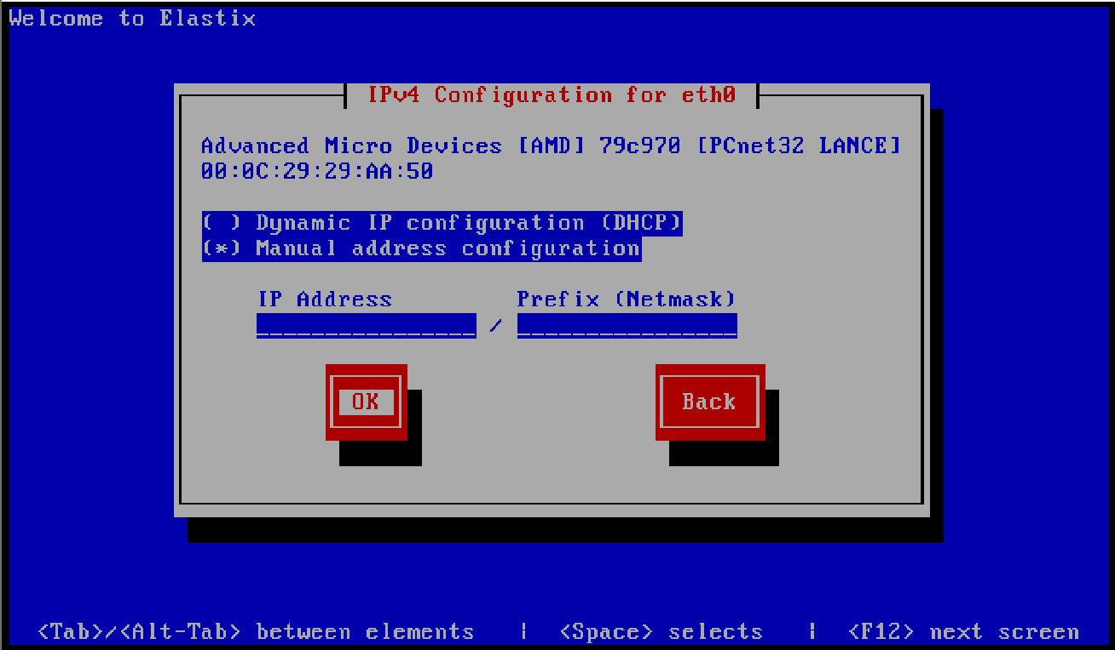

9. Next, enter the gateway address, the primary DNS address and the secondary DNS address, and then click ‘OK’ (Figure 9).
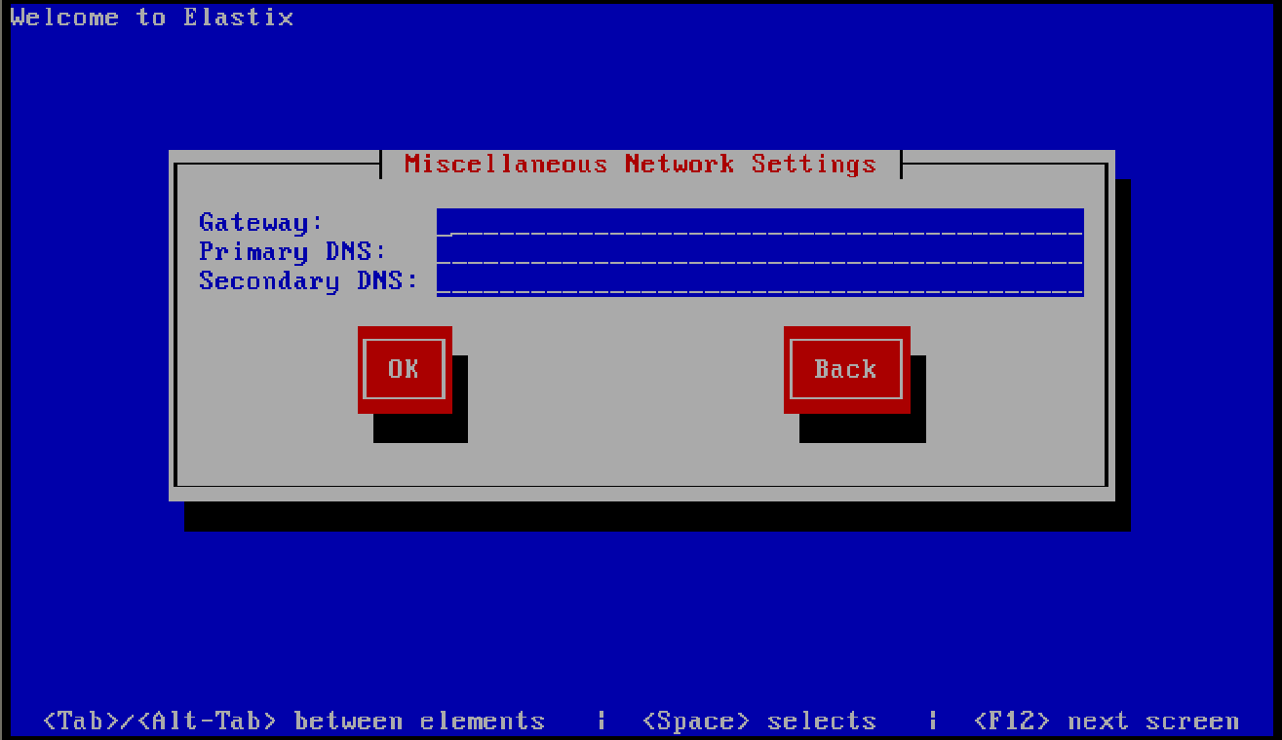

10. Next, determine how to get the hostname, assigned automatically via DHCP or entered manually. Here we select ‘manually’ and enter a hostname such as ‘voip’ on the dotted line (Figure 10).
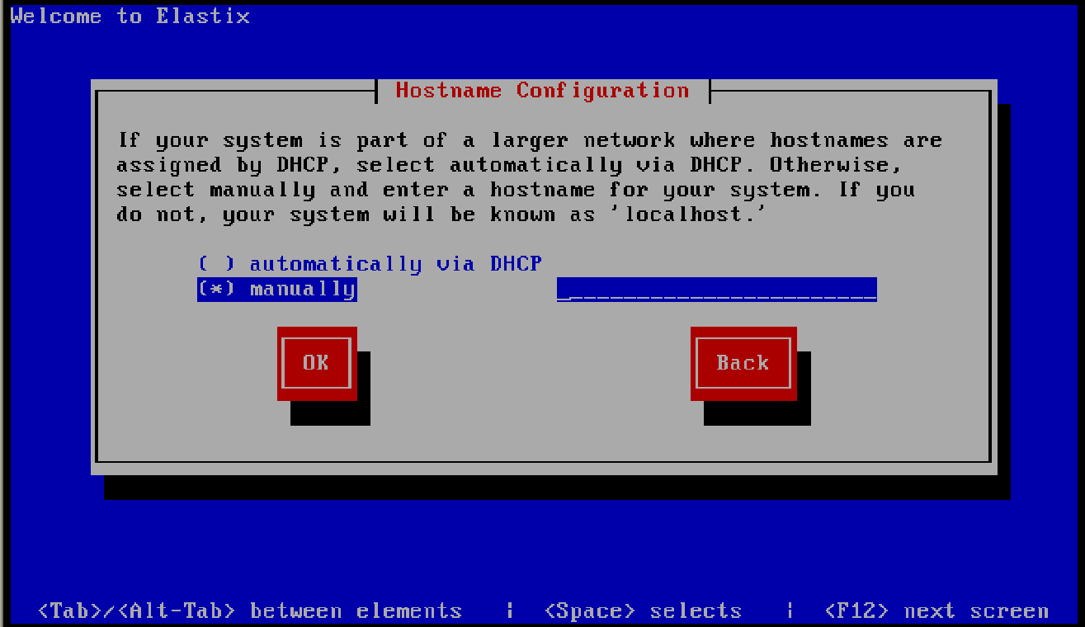
11. Next, select a time zone according to the real situation. Here we select ‘Asia/Dhaka’ (Figure 11).
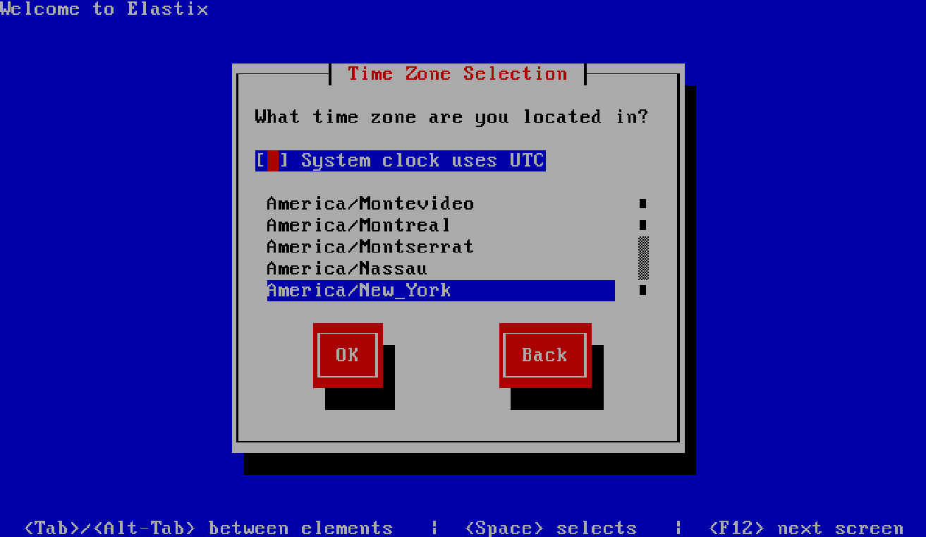

12. Next, enter the system administrator password (Figure 12).

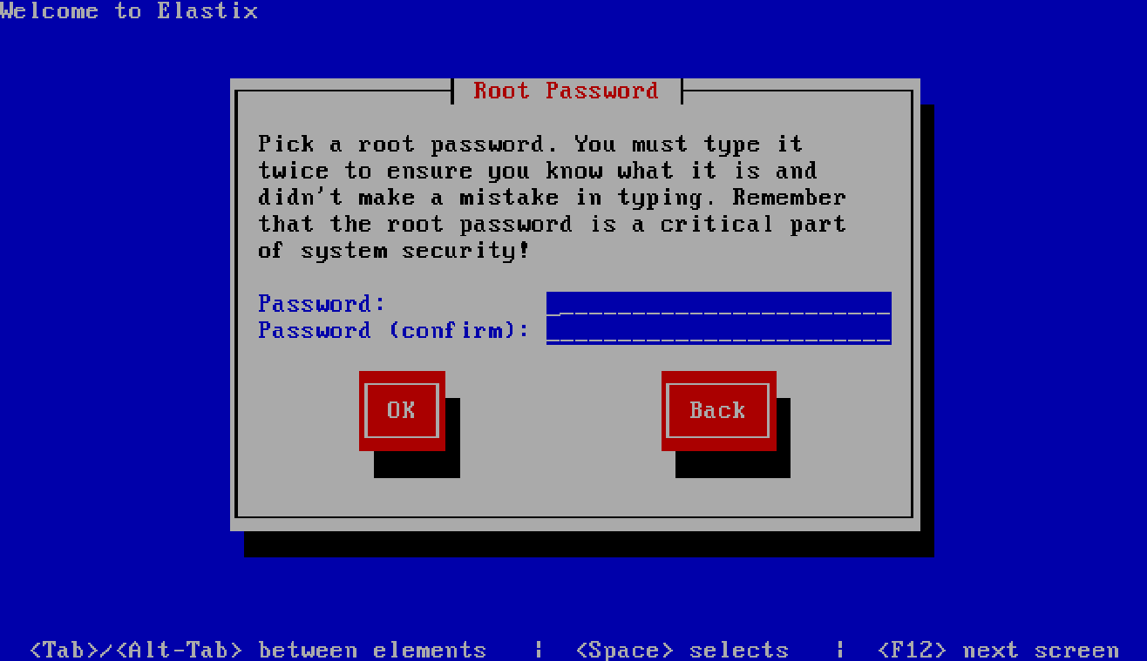

13. Next, the partitioning and formatting of the HDD begins. After that, the system installation starts. Upon all files being installed successfully, the PC will be restarted automatically (Figure 13).
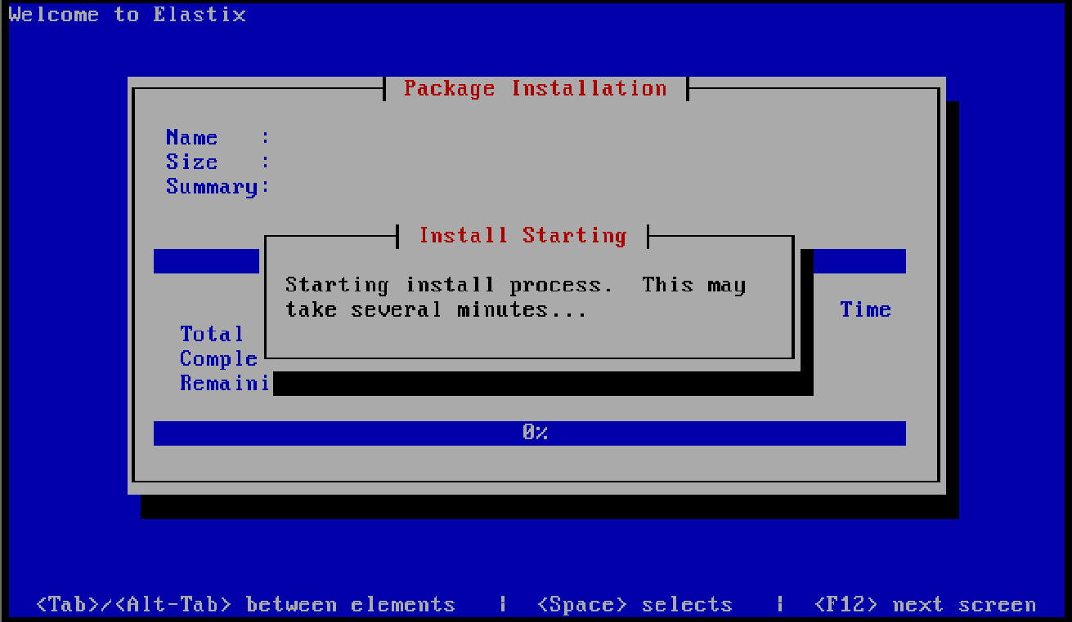
Note: You must take out the Elastix CD before the PC restart; or the system will go into the installation guide interface again.
14. After the PC restart, the system goes into the startup interface (Figure 14).
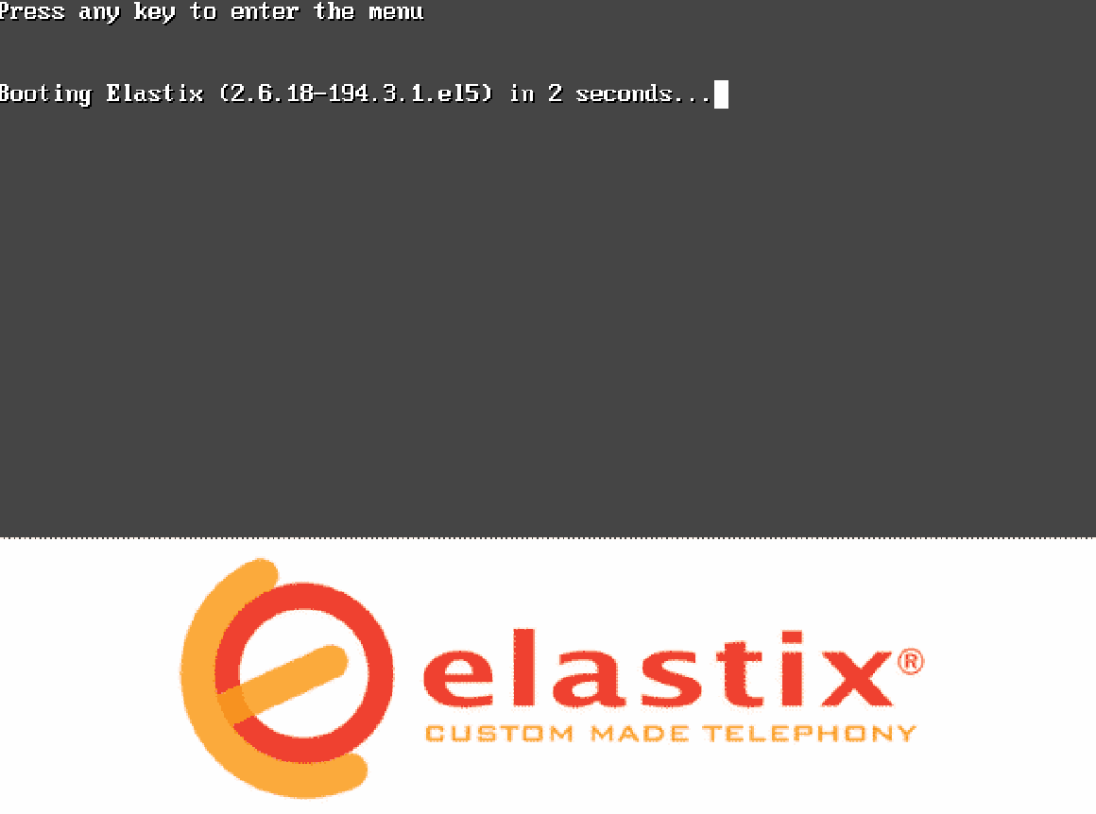
15. During the startup process, the following prompt will pop up to ask for a new MySQL root password. Here we can set any password as we want (Figure 15).
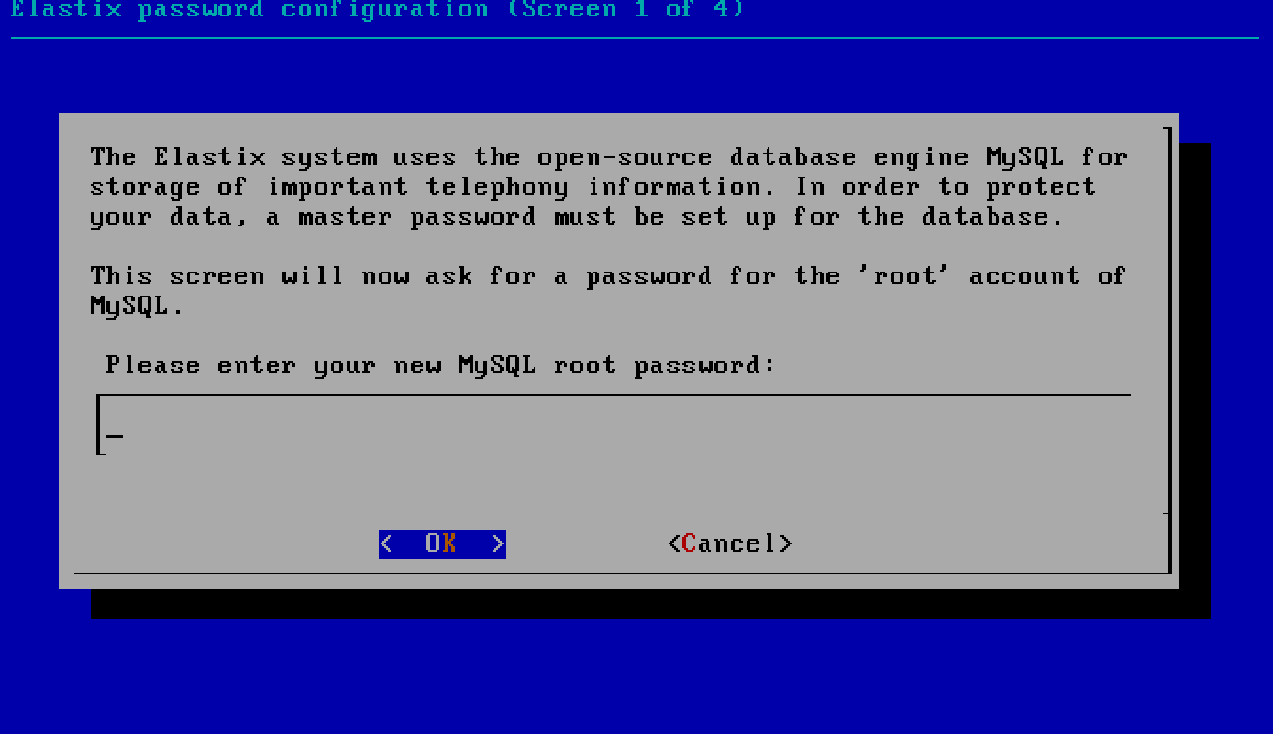

16. Also in the startup process, the following prompt will pop up to ask for a web login password. Here we can set any password as we want, such as ‘admin’ (Figure 16).

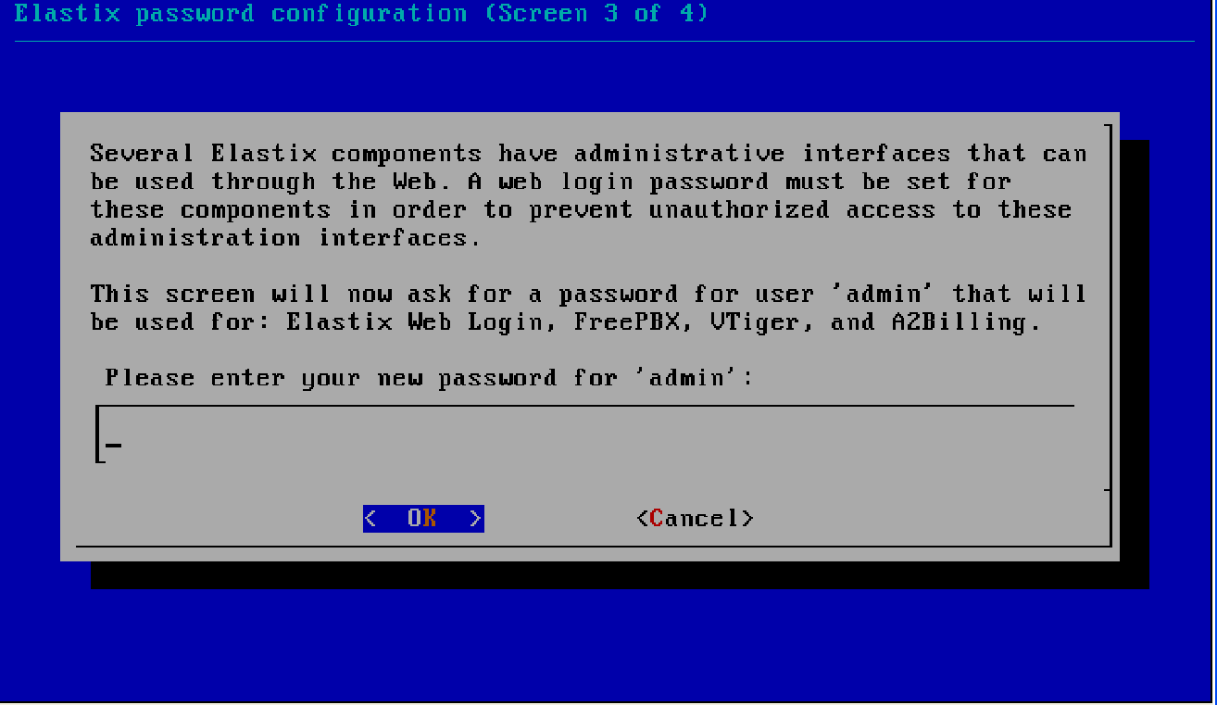

Step3: Log on the system
There pops up the login prompt after the system startup. Please use the root username to log in, and the password is just the one set during the installation process.

Step4: When all the above steps are finished, the Elastix operating system has been installed successfully.

Step 5 : Go to another PC open the internet browser and type the following URL
https://192.168.55.1
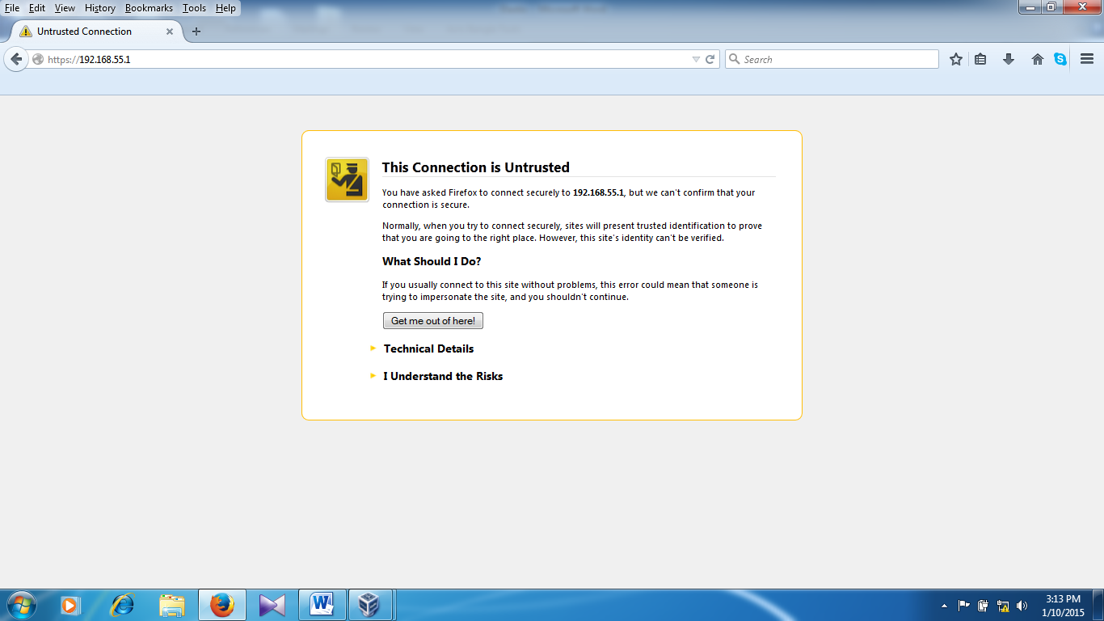

Click I Understand the risk
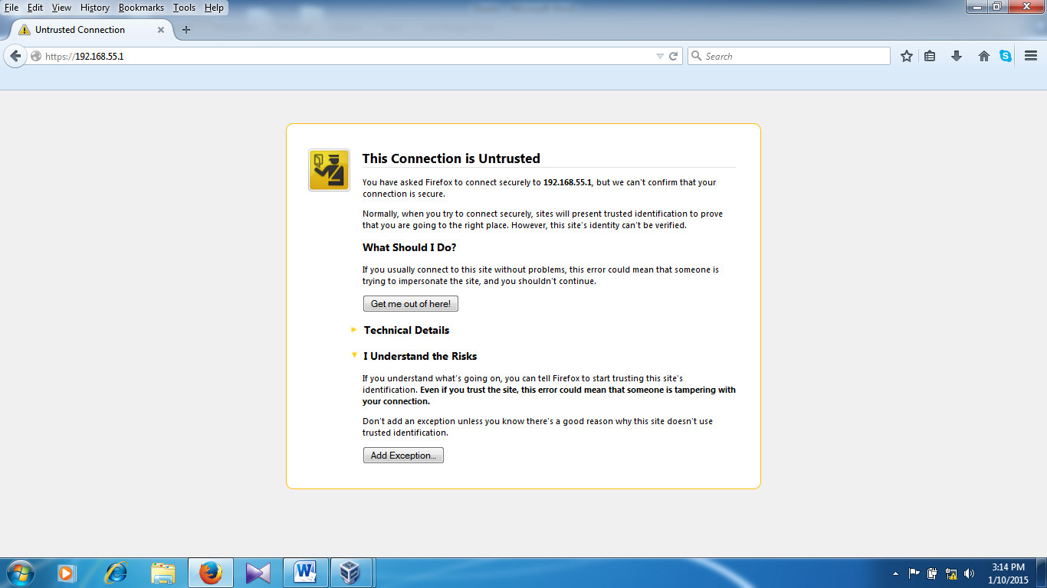

Click Add exception

Click Get certificate
Click on confirm security exception
Type user name admin and admin password as you given into the setup time.
Click Submit

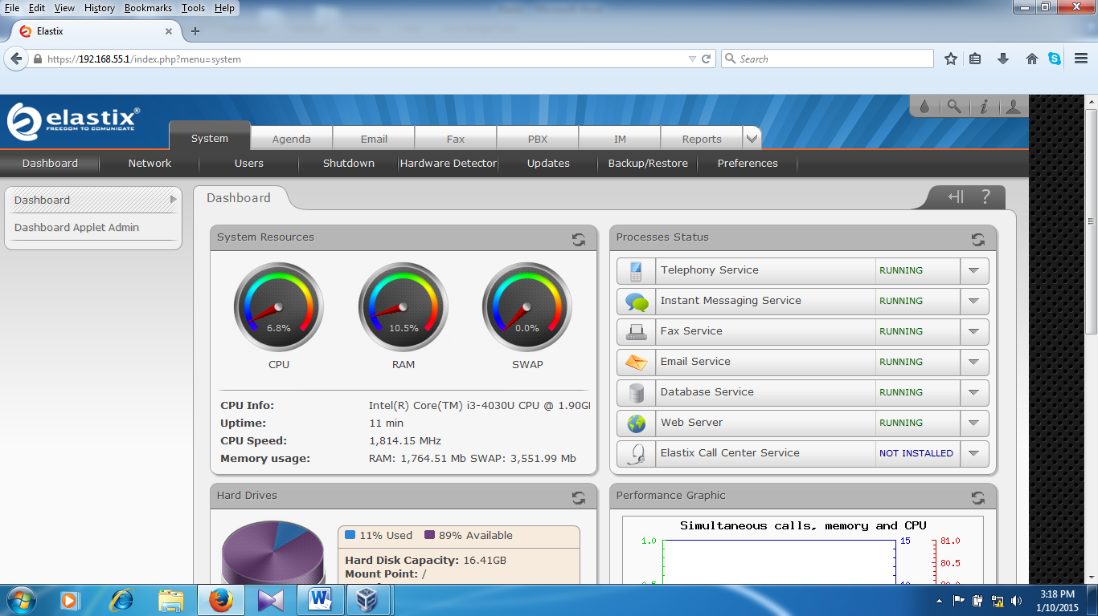
This is home page
Click on PBX for all type of configuration.

