How to add an extension or a telephone number
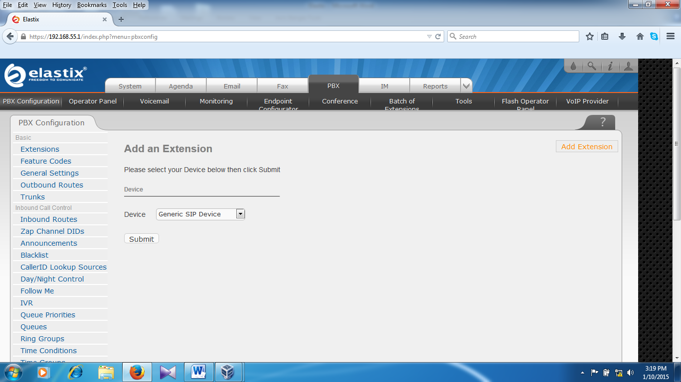
Select Generic SIP Device and click on submit
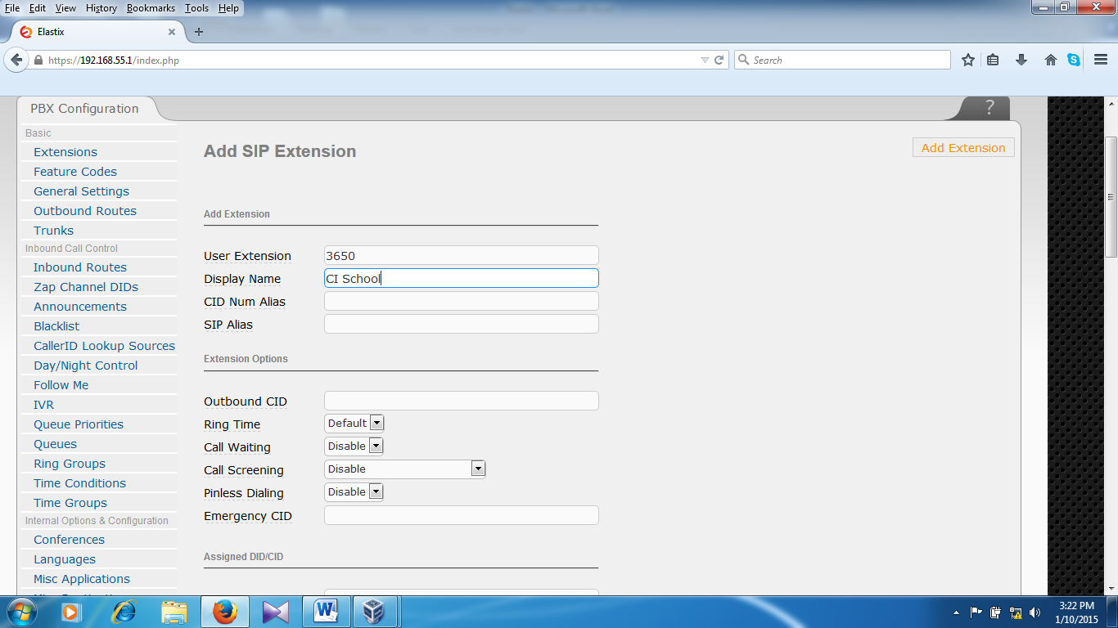

Type user extension : 3650
Display Name : CI School
Go to under the dialog box chose secret option for password
Then click on submit
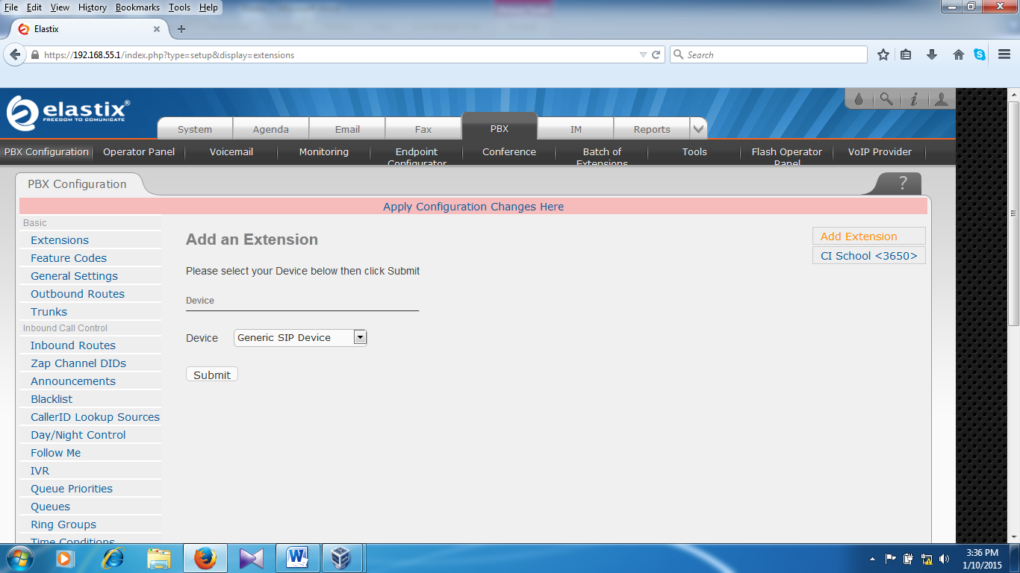
Click apply configuration changes here .New extension has been created.

Configure a software phone (Zoiper)

Click Here for Option

Click Add new SIP account
Put the name here like (CI school) and click OK or any other nam

Domain /Server IP : 192.168.55.1

User name : 3650
Password/Secret : 3650sip

Click on Apply
Click on OK
Now the software phone is ready to use.

Click here for dial pad
Backup and Restore

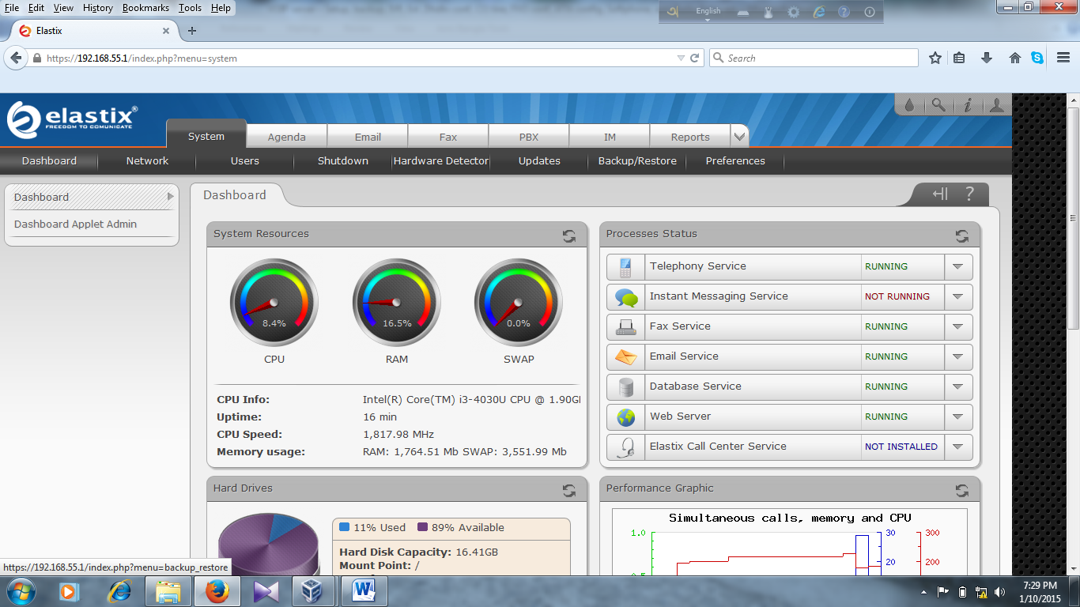

Go tosystem Backup/Restore
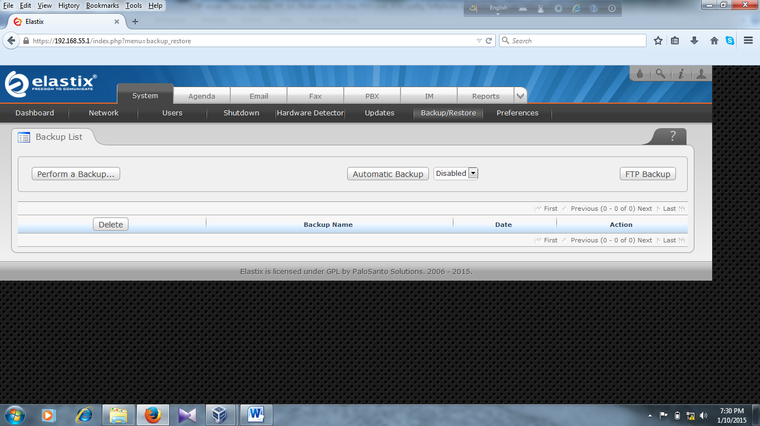

Click on Perform a Backup

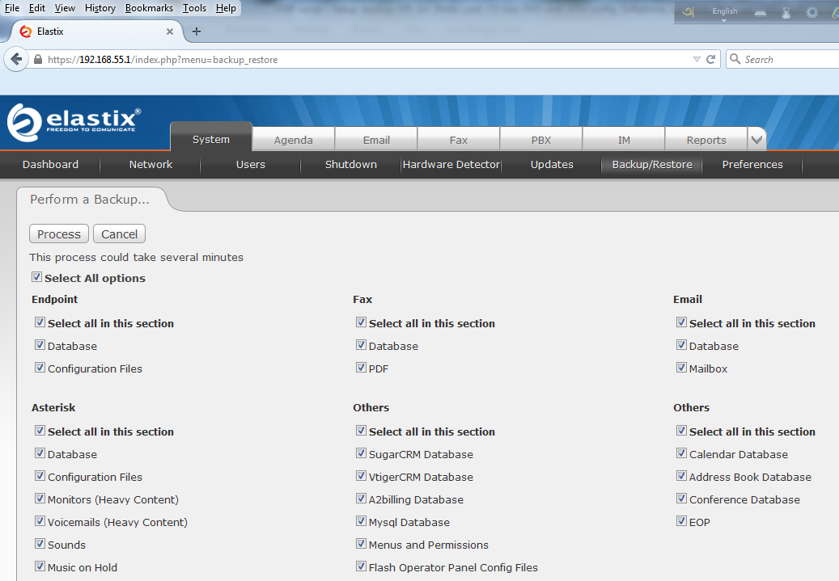

Select all options and click on Process
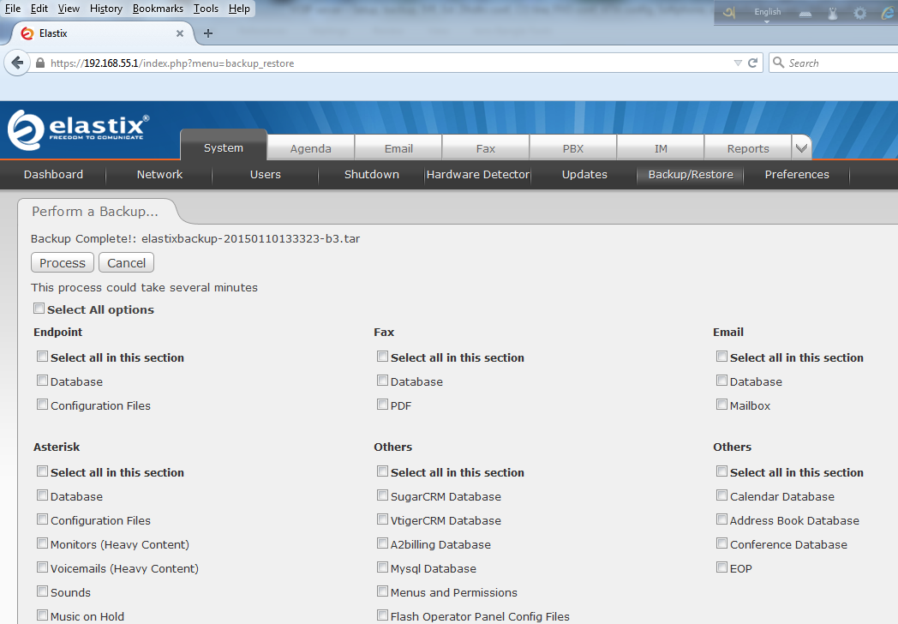

New backup is completed
To check new backup go to Backup/Restore.
You can see the following page.
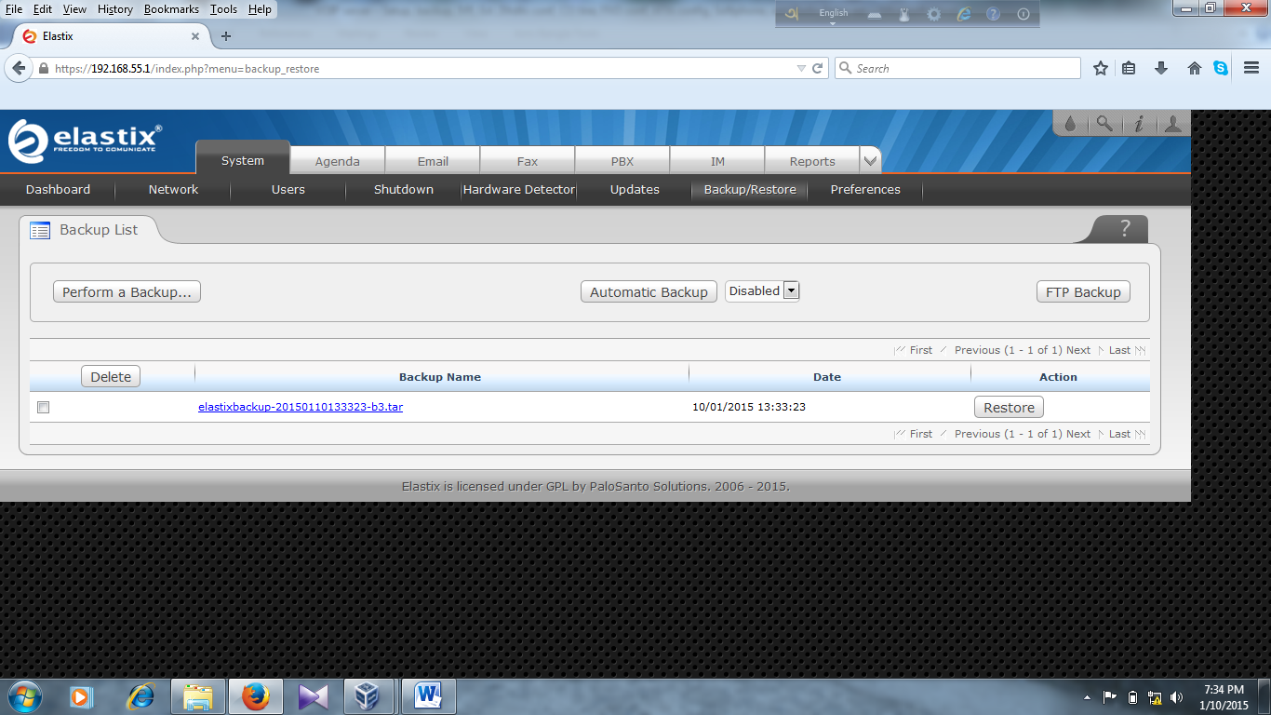
You can download the backup file by clicking here

Restore
Select the backup file (which file you want to restore) and click on Restor
Trunks
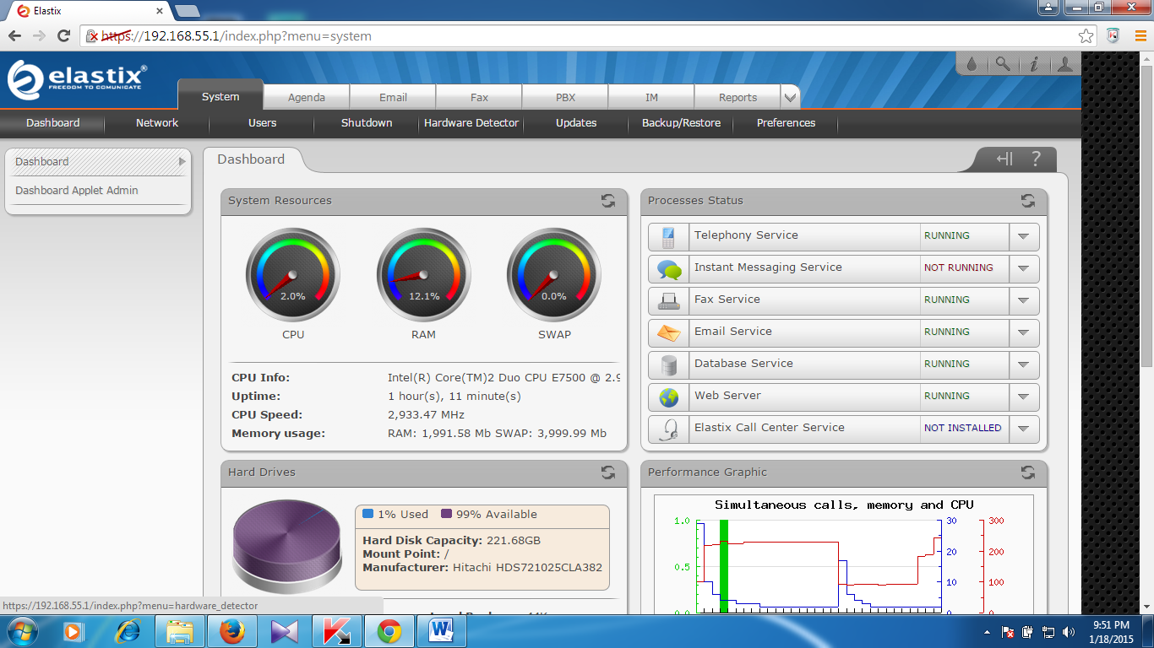

Click on System-Hardware detector (to check the digium card)
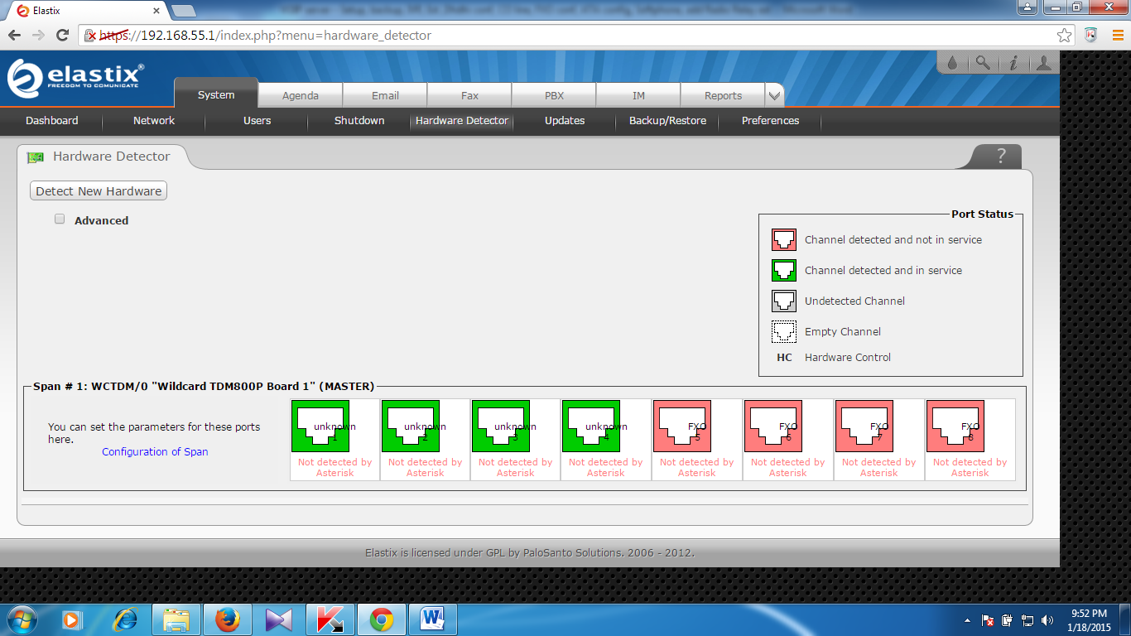

Click PBX-Trunks-Add DAHDI Trunk
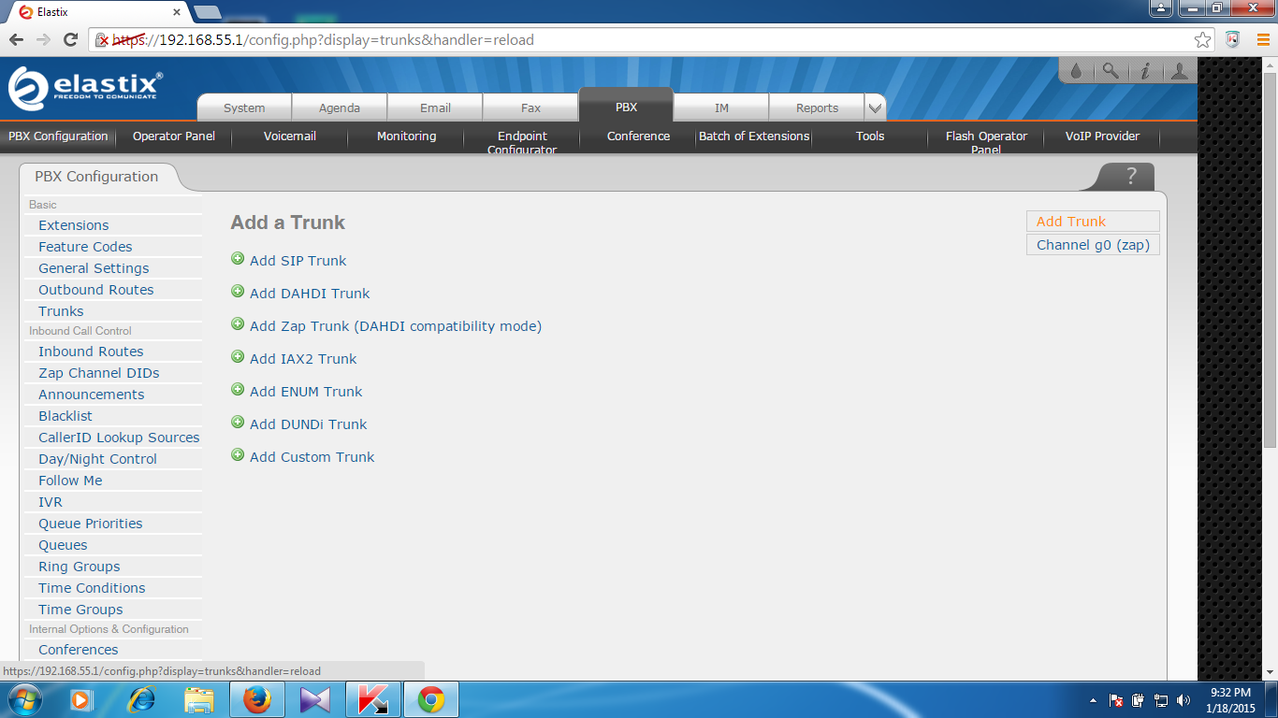

Fill up the following info as below
Trunk name :
Match pattern : .
DAHDI Identifier :

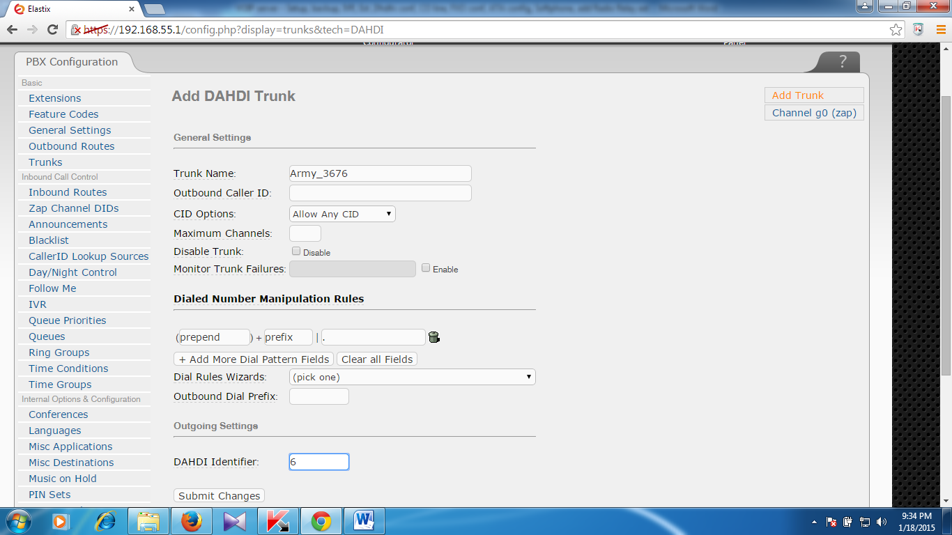

Now Submit Changes
Apply configuration changes here
Outbound Route
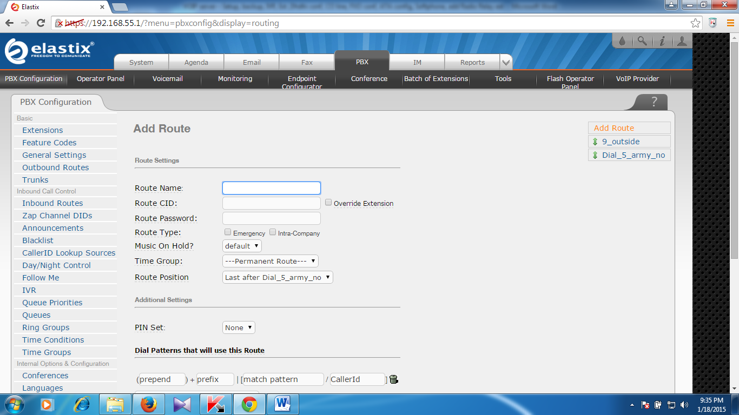
Click on Outbound Routes(from the left menu)
Fill up the following info as below
Route name :
Prefix :
Match pattern :
Trunk seq For Mached routes :

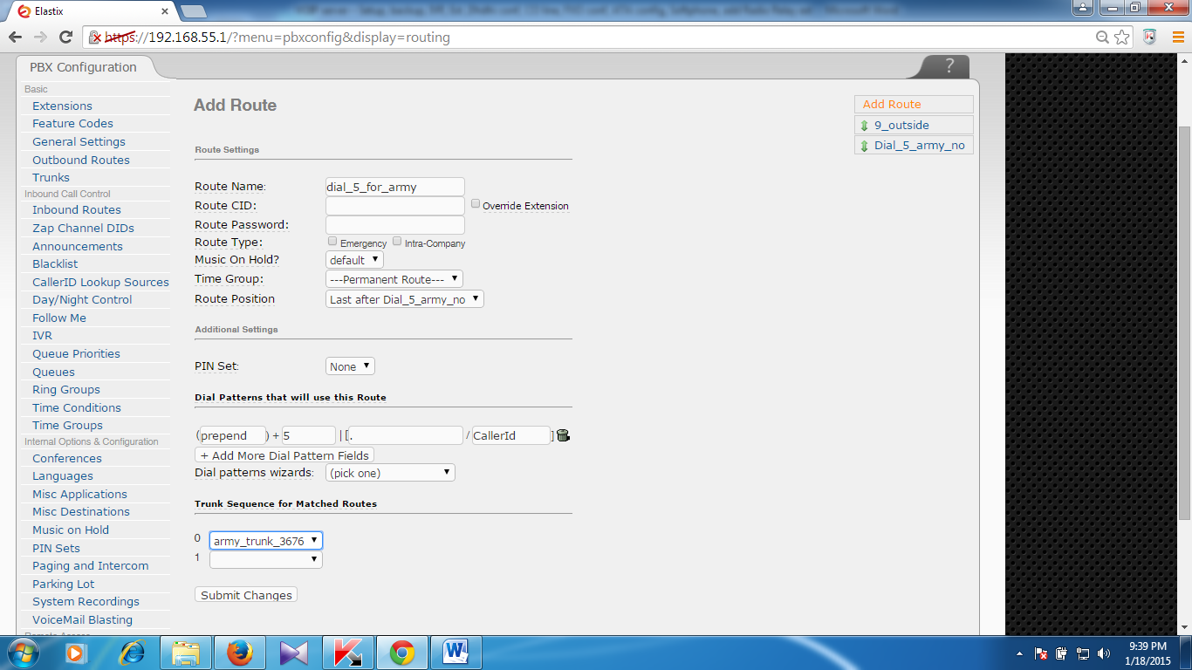
Apply configuration changes here

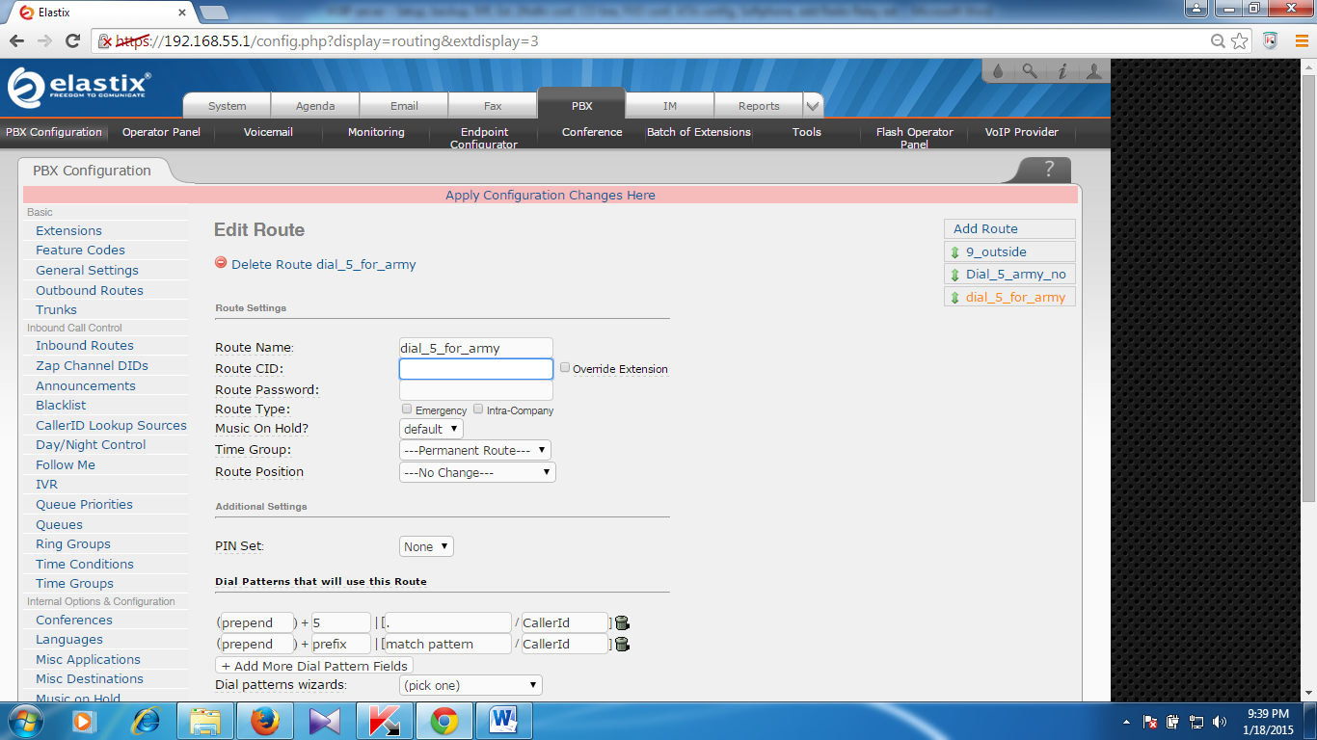
Inbound Routes
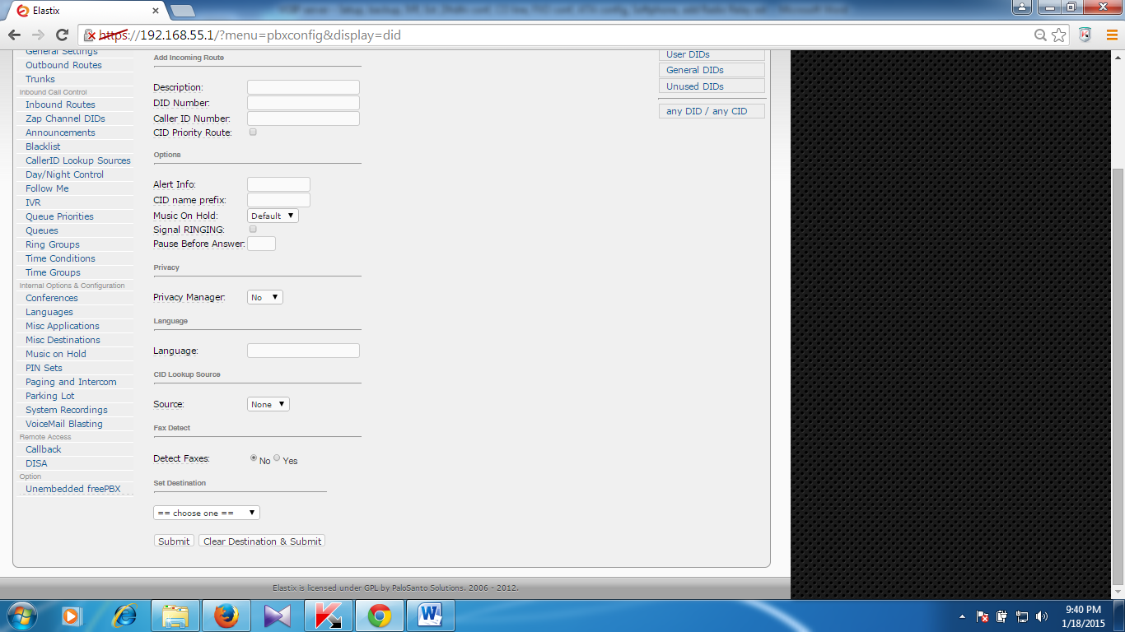
Click on Inbound Routes (from the left menu)

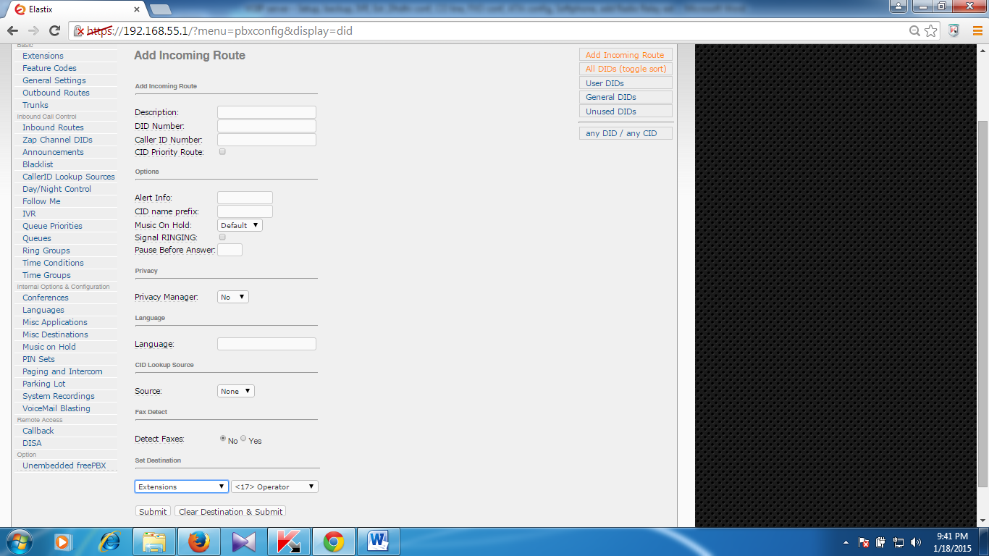

Select extensions as you want to use in your VOIP Operator.

IVR
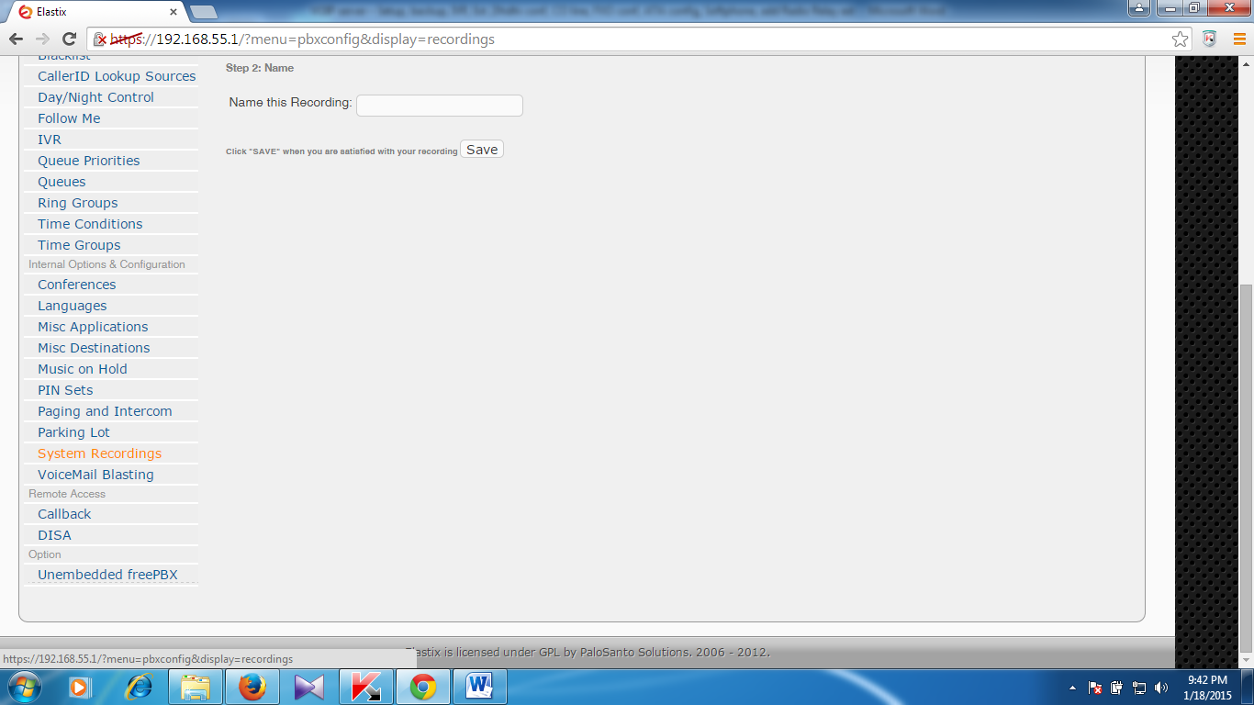
Click on system recording (from the left menu) for record your voice from IP phone or any other extensions

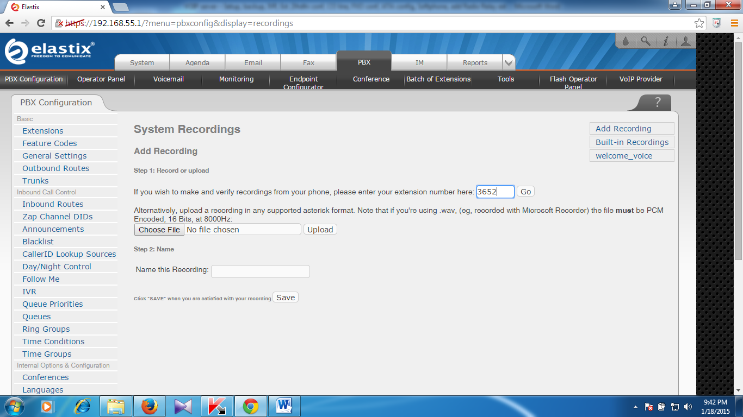

Type your extensions number to record voice
And click on Go
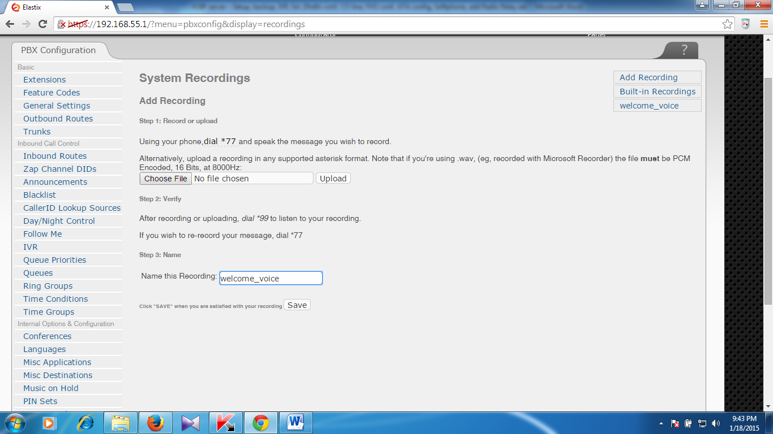
Name of the recording : welcome _voice

