Delete Administrator Account
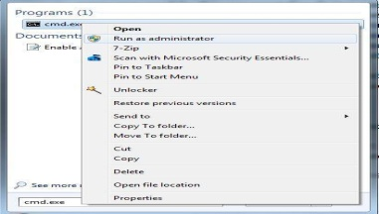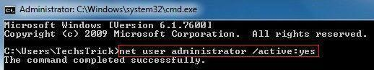
Search cmd.exe in start menu and run cmd.exe as administrator.
To enable Administrator account Type: net user administrator /active:yes
The command should execute successfully.Command line to disable this account: net user administrator /active:no

Step 2 From Local Users and Groups
Go to control panel navigate to Administrative tools and computer management.
Expand the Local users and Groups arrow and select Users. Then, From the right pane, double-click on the Administrator.
Un-check the "Account is disable" and it should be look like below.
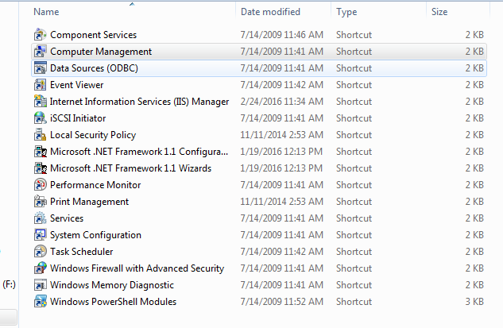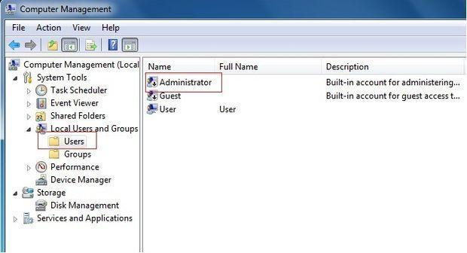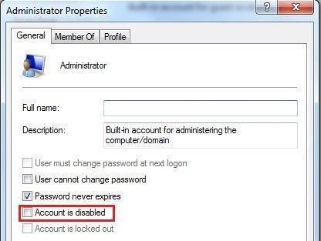
Type secpol.msc in start menu and run it as administrator.
Break forgotten windows 7 password
First time computer restart + f8 safe mode +command promdRun+cmd+net user administrator /active: yes
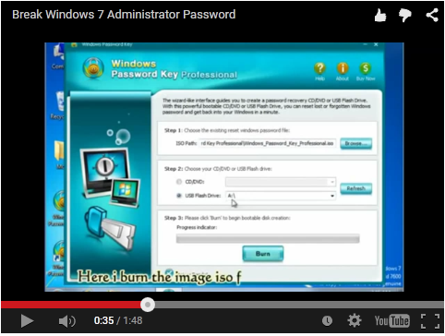

Change key board key layout
Click Start , type intl.cpl in the Start Search box, and then press ENTER. On the Keyboards and Language tab, click Change keyboards.ClickAdd.Expand the language that you want. For example, expand French (Canada).Expand Keyboard list, click to select the Canadian French check box, and then click OK.In the options, click View Layout to compare the layout with the actual keyboard.In the Default input language list, click French (Canada) – Canadian French, and then click OK two times.In the Regional and Language Options dialog box, click OK.
Microsoft key board layout creator 1.4 software
RemovingDual Boot Setup---Run+msconfig + deletRun

Enable/Disable Network interface via command line
Get NIC list and index number:
wmic nic get name, index
Enable NIC with index number: (eg: 7)
wmic path win32_networkadapter where index=7 call enable
Disable NIC with index number: (eg: 7)
wmic path win32_networkadapter where index=7 call disable

Make a FTP Server
Control Panel + Program And Futures+Turn on windows futures on or off + internet information service
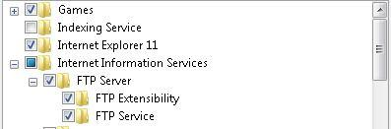
now -- administrative tools +internet Information services(IIS)Manager now site+add FTP next ip address + +next+ +finish
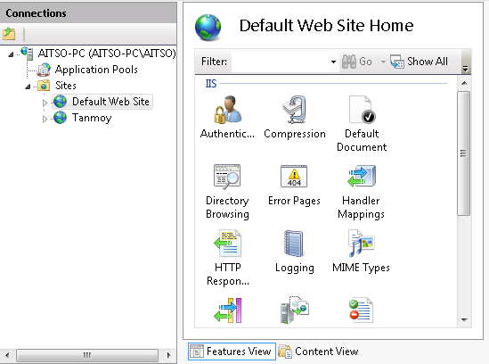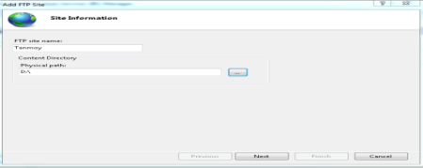
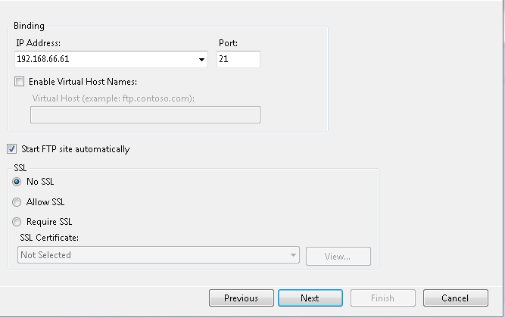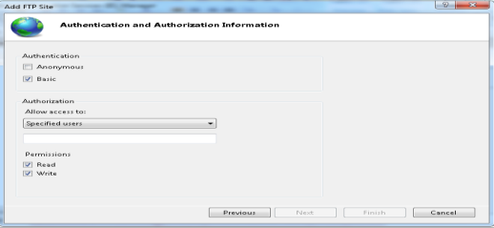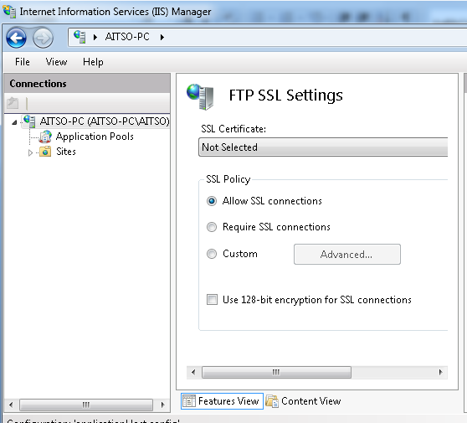
now control panel+ firewall+ allow a program or future thought windows firewall+ 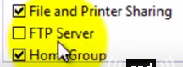finish

Windows shutdown ,restartcmd Shutdown Computer----Shutdown.exe -s -t 00 Restart Computer----Shutdown.exe -r -t 00Lock Workstation-----Rundll32.exe User32.dll,LockWorkStation Hibernate Computer-----rundll32.exe PowrProf.dll,SetSuspendStateSleep Computer------rundll32.exe powrprof.dll,SetSuspendState 0,1,0
Delete‘Run’ History (using Regedit):
Windows+R=RegeditNavigate to ‘HKEY_CURRENT_USER\Software\Microsoft\Windows\CurrentVersion\Explorer\RunMRU’
Disable Windows Installer
Gpedit.msc+administrative templates +windows components +windows installer +Prohibit user Installs+Enable +Hide +aplly + PC Restart
Block Windows Control Panel
HKCU\Software\Microsoft\Windows\CurrentVersion\Policies\Explorernow delete no control Panel
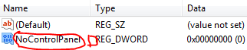nownew+DWORD(32-bit) now Rename nocontrolpanelvalue 1 Disable /value 0 Enable + restart

Delete Undeletable File
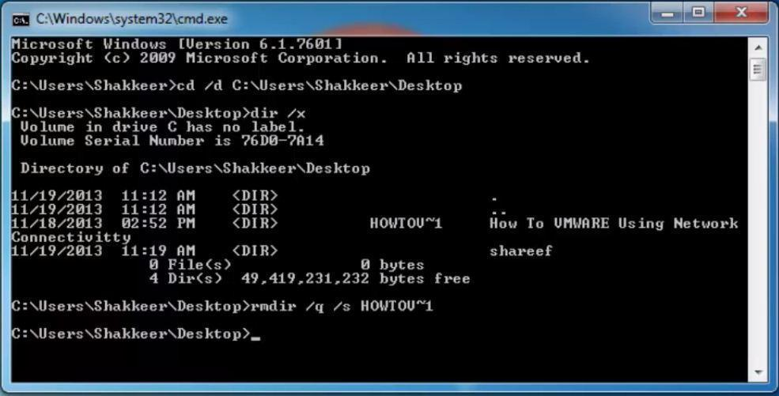
Windows Password Without Software
NEW +Text File +Open
cls
@ECHO OFF
title Folder Tanmoy
if EXIST "HTG Locker" goto UNLOCK
if NOT EXIST Tanmoygoto MDLOCKER
:CONFIRM
echo Are you sure you want to lock the folder(Y/N)
set/p "cho=>"
if %cho%==Y goto LOCK
if %cho%==y goto LOCK
if %cho%==n goto END
if %cho%==N goto END
echo Invalid choice.
goto CONFIRM
:LOCK
renTanmoy "HTG Locker"
attrib +h +s "HTG Locker"
echo Folder locked
goto End
:UNLOCK
echo Enter password to unlock folder
set/p "pass=>"
if NOT %pass%== PASSWORD_GOES_HERE goto FAIL
attrib -h -s "HTG Locker"
ren "HTG Locker" Private
echo Folder Unlocked successfully
goto End
:FAIL
echo Invalid password
goto end
:MDLOCKER
mdTanmoy
echoTanmoy created successfully
goto End
:End
Now save as Tanmoy.BAT +Enter if NOT %pass%== Tanmoygoto FAIL Tanmoy password now Y Hide and N show

Make Computer Speed
Search +power option+power saver (radio baton)+exit Cmd+msconfig=boot+advanceoption+number of proceessors(cheak baton) +2 +maximum memory (cheakbaton)enable 4096+ startup +need cheak baton (enable and disable) +apply ok
Block Delete Permission-- Example folder +Properties+Security+Advance+Owner +Pc name +Apply+oknow 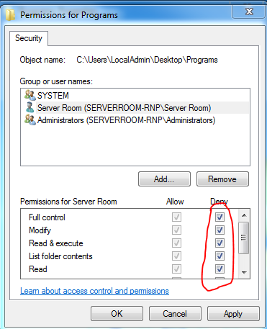
Remove Shortcut Virus From Pen Drive & SD Card Type in Command prompt :attrib -h -r -s /s /d I:\*.*
Remove viruses Without Antivirus Using CMDattrib -a -s -r -h *.* /s /dNow select infected drive and type attrib -s -h *.* /s /d in the command and hit EnterNow type dir and press EnterIt will show content of this drive and check if there is an unusual .exe file or Autorun.inf file.
• If you find any unusual file then rename it by typing Rename filename.extensionnewfilename. For example if you find Autorun.inf then type rename autorun.inf auto and press Enter.https://www.youtube.com/watch?v=zukiaiAbB4Q
DELETE LOG FILECommand prompt and type cd\del *.log /a /s /q /f
Make Computer Speed Part 2
Regedit +hkey local machin +system+currentcontrolset+sessionmanager+memory management +prefetchparameters (outside) enablesuperfetch value 0
Make Computer Speed Part 3My computer +manage + device manager (outside) disk drivers+ properties+policies + write-caching policy +enable My computer + properties+ advance system satting +advaced +performance –setting+ enable /disable Regedit+hkey current user + control panel +desktop(outside)+ manushowdelay+50
RENAME ADMINISTRATOR
Start->Control Panel->Administrative Tools -> Local Security Policy->Local Policies ->Security Options -> Select Account : Rename Administrator Account ->Right Click-> Properties -> (Give any name ) ->Apply-> OK

DISABLE USB PORT
Start -> Run ->Regedit ->Hkey Local Machine -> System -> Current Control Set -> Services -> USBSTOR -> Right Click on Start -> Modify
-> Give The Value Greater than 3
APPLY STRONG PASSWD POLICYStart -> Control Panel -> Administrative Tools -> Local SecurityPolicy -> Account Policies -> Password Policy -> Change the value as per your Requirement -> Apply -> OK
APPLY ACCT LOCKOUT POLICY
Start -> Control Panel -> Administrative Tools -> Local Security Policy -> Account Policies -> Account Lock Out Policy -> Change the value as per your Requirement -> Apply -> OK
CONFIGURE AUDIT POLICIES
Start -> Control Panel -> Administrative Tools -> Local Security Policy -> Local Policies -> Audit Policy -> Change the value as per your Requirement -> Apply -> OK
Block Firefox Download
Tools+add-ons+search …write public fox blocksite +install +restart firefox tools +add ons+extensions (outside) public fox1.10.1-signed options General all enable
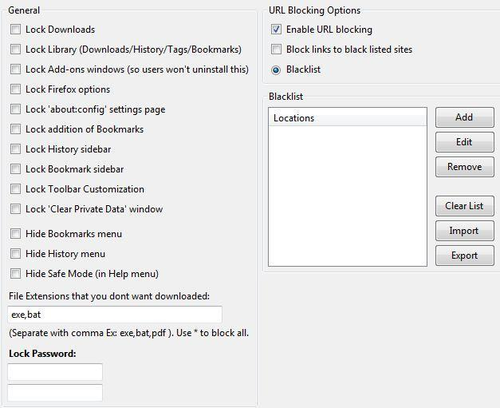
Block FirefoxWebsideTools+add-ons+search …write blocksite +install +restart firefoxagain tools +add ons+extensions (outside) blocksiteoptions authentication enable new password add webside name +ok+ok ..and don’t open the selected website Firefox Run FasterFirefox+properties +shortcut +target +"C:\Program Files\Mozilla Firefox\firefox.exe" /prefetch:1

Why Youtube Buffering is Slow
start + search option write administrative tools +Windows Firewall with Advanced Security
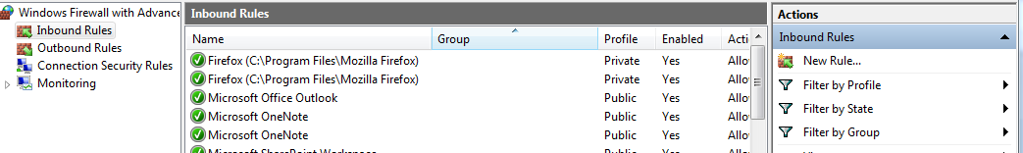
New roles + custom + next + all program + next + next + which remote ip address does this rule apply to +these ip address + add + 206.111.1.0/16 + next + block the connection + next + next name writeyoutube + finished
Don’t run specified Windows applications

gpedit.msc+User Configuration +Administrative Templates+System+Don’t run specified Windows applications+enable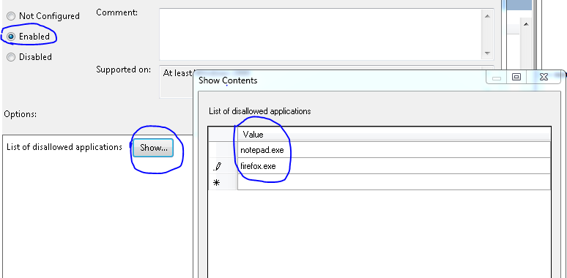

Restrict Programs from being installed via Registry Editor

HKEY_CURRENT_USER\Software\Microsoft\Windows\Current Version\Policies\Explorer-right click-new createDWORD(32-bit)-renameDisallowRun value 1 now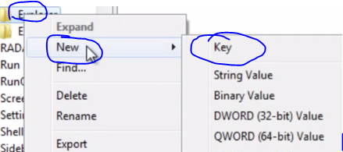rename DisallowRun now 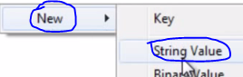rename example paint value data 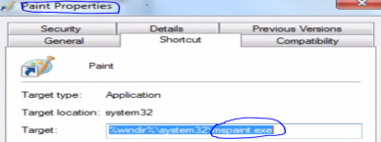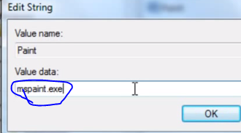now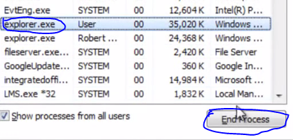run+explorer.exe

Clear Past Notification Icons In Windows 7
Regedit+HKEY_CURRENT_USER\Software\Classes\Local Settings\Software\Microsoft\Windows\CurrentVersion\TrayNotify now right click Export on save on desktop now delete 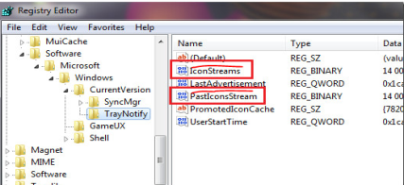 now run + explorer.exe
Enable or Disable Balloon Notifications Using Group Policy
Gpedit.msc + User Configuration, Administrative Templates, then click/tap on Start Menu and Taskbar +double click/tap on Turn off all balloon notifications+To Enable Balloon Notifications+To Disable Balloon Notifications+Not Configured or Disabled+Close the Local Group Policy Editor.
GPEdit.msc Windows 8.1 Missing linkhttps://docs.google.com/uc?export=dow...
At First Install gpedit.msc Software now C Drive + windows + sysWOW64+groupPolicy copyand minimize now C Drive +Windows+ Sysdem32 paste groupPolicy
Now copy groupPolicyuser and paste Windows+ Sysdem32. Now C Drive + windows + sysWOW64+ipmi+gpedit.msc copyand paste Windows+ Sysdem32 nowWindows+R= gpedit.mscokkks

Speed up your Internet Connection for Windows 7,8,8.1,10
My ComputerRightclickProperties Advance System Setting +system protection +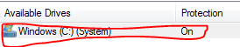++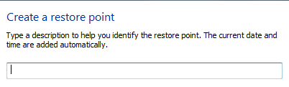Write Restore +oknow Navigate to "HKEY_LOCAL_MACHINE\SOFTWARE\Microsoft\Windows\CurrentVersion\ new 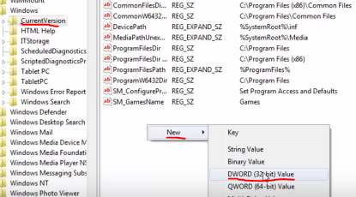now Rename +MaxConnectionsPerServer value 16 Againnew+DWORD(32-bit)value +Rename MaxConnectionsPer1_0Servervalue 16 Close Registry Editor now windows+r =gpedit.msc +Computer Configuration+ Administrative Templates+network+QoS Packet Scheduler+Double click on Limit reservable bandwidth and Disable it.

Double your Internet Speed using CMD

Open cmd as administrator+ cd/+ netshinttcp show global+netshinttcp set global chimney=enabled + netshinttcp set global autotuninglevel=normal + netshinttcp set global congestionprovider=ctcp netsh interface tcp show heuristics netsh interface tcp set heuristics disabled
HOW TO DELETE LOG FILE
command prompt and type cd\del *.log /a /s /q /f
How to creat a laptop wifi hotspot
Netshwlan show drivers
Netshwlan set hostednetwork mode=allow ssid=tanmoy key=password
Netshwlan start hostednetwork
Delete a Write Protected File or Undeletable Files or Virus
Cmd Cd/ Cls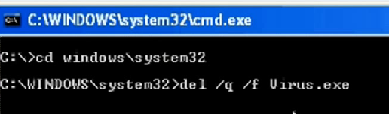https://www.youtube.com/watch?v=aukJzEVKVeo
Cannot Delete a Folder or File
Cd / d C:\Users\Aitso\Documents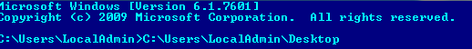Dir/x
Rmdir /q /s savedg~1

Shut Down Services Faster

HKEY_LOCAL_MACHINE\SYSTEM\CurrentControlSet\Control and double-click the string WaitToKillServiceTimeout on the right-hand side. Change the value from 12000 to 2000 and click OK. Services will now be shut down after 2 seconds

Use Basic Commands

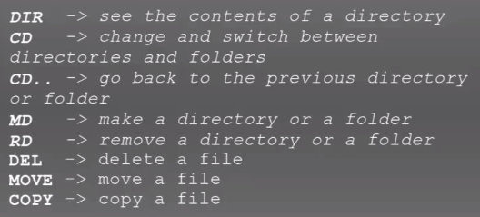Cd/+dir +cd users+cdlocaladmin+dir+cddesktop+mdtanmoymdফোল্ডার বানানোর জন্য + rdtanmoy+rd folder delete korerjonno+mdtestfolder (folder create korlumekon create etc.testfile.txt )+copy testfile.txt testfolder (for file copy )+cd testfolder+dir+cd+ del testfile.txt +https://www.youtube.com/watch?v=MNwErTxfkUA

Windows 8enable classic Start Menu without any additional software
1st library +Open New Library+ Rename Start+ Properties +add+ folder name likthehobe%HOMEDRIVE%\ProgramData\Microsoft\Windows\Start Menu\+ again add+ Folder name likthehobe%HOMEDRIVE%%HOMEPATH%\AppData\Roaming\Microsoft\Windows\Start Menu\+apply now
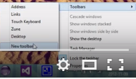ekon new toolbar a giya library start select koradithehobe .ekonei symbol ta diyadrakkora sob asbe.
Windows 8 Start Button Download link … 1st/ http://www.classicshell.net/downloads/2ndhttps://code.google.com/archive/p/power8/downloads

Torrent Download Link--- https://kat.cr/https://torrentz.eu/

Block Cmdgpedit.msc+User Configuration +Administrative Templates + System +Prevent access to Command Prompt +Enabled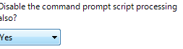windows + Run =gpupdate /force then Update https://www.youtube.com/watch?v=B49eJS0G0G4

Block RegeideGpedit.msc + User Configuration +Administrative Templates+ System +Prevent access to Registry editing tools + Enabled

windows + Run =gpupdate /force then Update

Block SpecifyProgramGpedit.msc + User Configuration +Administrative Templates+ System+ Don’t Run specified Windows applications +Enabled+ + Example 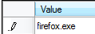windows + Run =gpupdate /force then Update
Block Windows Control PanelGpedit.msc + User Configuration +Administrative Templates+Control Panel + Prohibit access to Control Panel +Enable windows + Run =gpupdate /force then Update
Block Windows Desktop Gpedit.msc + User Configuration +Administrative Templates+Desktop+Hide and Disable all Items on the Destop +Enable
Block C Drive Gpedit.msc + User Configuration +Administrative Templates+Windows Components + Windows Explorer + Prevent access to drivers From my computer +Enable +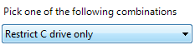windows + Run =gpupdate /force then Update

Remove write protection from USB Flash driveCmd+Diskpart+List disk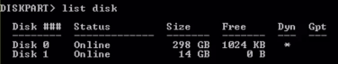+Select disk 1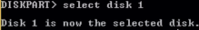+attributes disk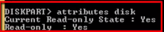+attributes disk clear readonly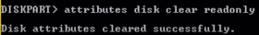 +attributes disk set readonly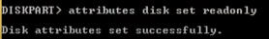 +exit https://www.youtube.com/watch?v=wgpNJX-yEek
Windows is not genuineCmd+ SLMGR -REARM +exit

Make/Remove USB Storage Devices as Read Only Cmd+regedit+HKEY_LOCAL_MACHINE\SYSTEM\CurrentControlSet\Controlekon control erupor Write click kora Export korthehobe desktop a Now control write clicknew+keyrename StorageDevicePoliciesnow new +DWORD(32-bit) Value

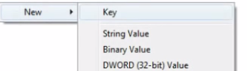renameWriteProtectnow value 1 enable 0 disable https://www.youtube.com/watch?v=YAVwYZ2vx5csandeepsingh

How to Disable/Enable Folder Options

Group Policy window please navigate to User Configuration ->Administrative Templates ->Windows Components -> Windows Explorer and open Removes the Folder Options menu item fromthe Tools menu ++Enable
Rule 2
Windows+R=RegeditNavigate to ‘HKEY_CURRENT_USER\Software\Microsoft\Windows\CurrentVersion\Explorer\policies/explorer/ outside new clickCreate 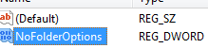+value 1 enable 0 disable

how to disable run commandGpedit.msc + User Configuration +Administrative Templates+Startmanu and Taskber+Remove Run Manu for Start menu + Enable

HOW TO DISABLE SEARCH HISTORYNavigate to User Configuration \ Administrative Templates \ Windows Components \ Windows Explorer then double click on “Turn off display of recent search entries in the Windows Explorer search box”.

Disable Windows Search
User Configuration > Administrative Templates > Start Menu & Taskbar > Remove Search link from Start Menu Ensure that Remove Search link from Start Menu is Disabled or Not Configured.
Format Drive Commandformat s: /y /q /fs:NTFS
Get Multiple Desktop https://technet.microsoft.com/en-us/sysinternals/cc817881

How to remove bios password

1st time download the Cmos password recovery tools 5.0 (free)and cut the paste c drive
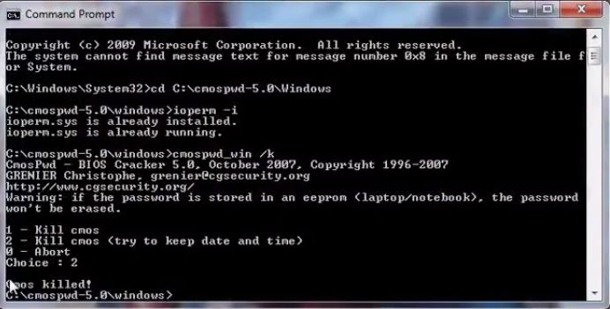
Fast Firefox about:config search Pipelining true add ons+ Fasterfox
Cmd Codes telnet towel.blinkenlights.nl
Start Button Wrong Work Troubleshooting suggestion only......
Right click at Start button > select Command Prompt (Admin) > at the flashing prompt, copy/paste this.....
sfc /scannow
> press Enter.now cmd powershell Enter type Get-AppXPackage -AllUsers | Foreach {Add-AppxPackage -DisableDevelopmentMode -Register "$($_.InstallLocation)\AppXManifest.xml"} now Dism /Online /Cleanup-Image /ScanHealth

How to find wifi password https://www.youtube.com/watch?v=4oJcHWC4hWo&nohtml5=False
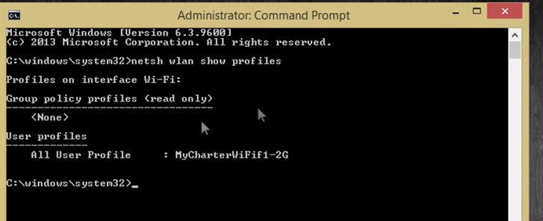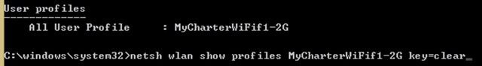
Block Sharing Option on Windows
Gpedit.msc + Local Computer Policy/User Configuration/ Administrative Templates/ Windows Components/ and Network Sharing. In the details pane, double-click Prevent users from sharing files within their profile. To enable the Group Policy setting, and disable the user's ability to share files, click Enabled.
Excel Font Color Alt+H+F+C Fill Color Alt+H+H

Checking file system in C
run the command fsutil dirty query C: then the command to disable chkdsk from scanning the C: drive would be: chkntfs /x c: next chkntfs /x c: d: now download Download Autocheck Boot Exclude.bat

regedit + HKEY_LOCAL_MACHINE\SYSTEM\CurrentControlSet\Control\Session Manager

this would modify the registry entry to “autocheck autochk /k:C *”.

Enable or Disable OSK Via Registry Windows Key and press “R” to bring up the “Run” dialog. Type “regedit“, then press “Enter“.HKLM SOFTWARE Microsoft Windows CurrentVersion Authentication LogonUI Open “ShowTabletKeyboard” and set it to “1” to enable it. Set it to “0” to disable it.

Remote Shutdown netstat –n shutdown –I

Command

ipconfig /allIP Configuration (Display Connection Configuration)ipconfig /displaydnsIP Configuration (Display DNS Cache Contents)
ipconfig /flushdnsIP Configuration (Delete DNS Cache Contents) ipconfig /releaseIP Configuration (Release All Connections)
ipconfig /renewIP Configuration (Renew All Connections) ipconfig /registerdnsIP Configuration (Refreshes DHCP & Re-Registers DNS)
ipconfig /showclassidIP Configuration (Display DHCP Class ID)ipconfig /setclassidIP Configuration (Modifies DHCP Class ID)

System File Checker=sfc /scanno Tasklist=tasklistTasklist –svc Tracert=tracert

Command
powercfg.cpl Power Configuration appwiz.cpl Program and Features timedate.cpl Date and Time Properties desk.cpl Display - Screen Resolution mmsys.cpl Sound Properties (Multimedia System Settings) wscui.cpl Security Center (Windows Security Center UI) sysdm.cpl
System Properties firewall.cpl Windows Firewall c: Explorer C: Drive regedit Registry Editor services.msc Windows Services (local) taskmgr Task Manager msconfig System Configuration mstsc Remote Desktop (Microsoft Terminal Services) logoff Log Off Windows (without confirmation!) calc Calculator notepad Notepad
Microsoft System Configurations

devmgmt.msc Device Management compmgmt.msc Computer Management diskmgmt.msc Disk Partition Manager gpedit.msc Group Policy Editor secpol.msc Local Security Policy Settings lusrmgr.msc Local User and Groups perfmon.msc Performance Monitor fsmgmt.msc Shared Folders (File Sharing Management)
Other Windows Tools

shrpubw Create a shared folder Wizard dxdiag Direct X Troubleshooter cleanmgr Clean Manager magnify Windows Magnifier osk On Screen Keyboard msinfo32 System Information sndvol Volume Control winver Windows Version comp Compare Files label Volume Serial fsquirt Bluetooth Transfer Wizard verifier Driver Verifier Utility sigverif File Signature Verification Tool joy.cpl Game Controllers eudcedit Private Characters Editor

Applications (if installed)
photoshop Adobe Photoshop ccleaner Ccleaner chrome Chrome excel Microsoft Excel access Microsoft Access powerpnt Microsoft Powerpoint winword Microsoft Word wmplayer Windows Media Player write Wordpad mspaint Paint

POE | Power Over Ethernet | PPP (Point-to-Point Protocol) Over Ethernet

EXE Directly executable program (MSDOS)
(EIGRP) Enhanced Interior Gateway Routing Protocol BAT Bulk Administrative Tool

Fix: A referral was returned from the server Error
Gpedit.msc+Computer Configuration > Windows Settings > Security Settings > Local Policies > Security Options. Look at the right pane and double click at “User Account Control: Only elevate executables that are signed and validated” policy, Change the security setting to Disabled and click OK.

Remove Shutdown and Restart Buttons In Windows 7

Local Group Policy Editor navigate to User Configuration \ Administrative Templates \ Start Menu and Taskbar and double click on Remove and prevent access to the Shut Down, Restart, Sleep, and Hibernate commands +enable

Lock The Taskbar

Local Group Policy Editor navigate to User Configuration \ Administrative Templates \ Start Menu and Taskbar and double click on Lock The Taskbar+ enable

Lock the Start Menu
Start > Run > Regedit> HKEY_CURRENT_USER > Software > Microsoft > Windows > CurrentVersion > Policies> Click on the Edit menu > New > Key> Name it as "Explorer" Select the Key Click on the Edit menu > New > DWORD Value 32 bits. Name this value as "NoChangeStartMenu" and set it's value to "1"
gpedit.msc/ User Configuration > Administrative Templates > Start Menu and Taskbar/ In the right pane, navigate to "Prevent changes to Taskbar and Start Menu Settings.enable

Enable or disable right-click context menus in Explorer

User Configuration > Administrative Templates > Windows Components/windows Explorer / Remove File Explorer’s default context menu/enable

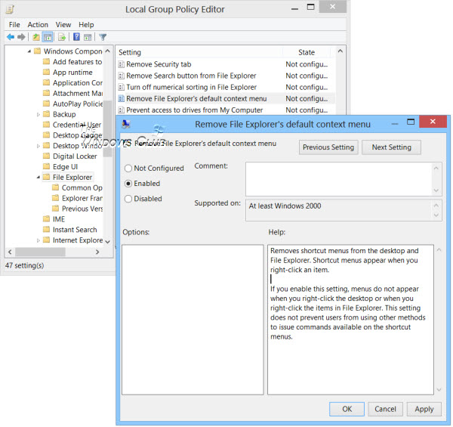
Using Registry Editor
HKEY_CURRENT_USER\Software\Microsoft\Windows\CurrentVersion\Policies\Explorer
Right-click in the right pane and create a new 32-Bit DWORD value and name it NoViewContextMenu. Giving it a value of 1 will disable context menu in File Explorer. To re-enable context menu, give it a value 0 or delete NoViewContextMenu.

High Contrast Shift+ Alt+ Print Scm Windows Version windows key + Pause Break

